МИНОБРНАУКИ РОССИИ

Федеральное государственное бюджетное

образовательное учреждение высшего образования

«ЧЕРЕПОВЕЦКИЙ ГОСУДАРСТВЕННЫЙ УНИВЕРСИТЕТ»

Институт информационных технологий

*наименование института(факультета)*

Кафедра математического и программного обеспечения ЭВМ

*наименование кафедры*

Теория автоматов и формальных языков.

*наименование дисциплины в соответствии с учебным планом*

ЛАБОРАТОРНАЯ РАБОТА №3-4

Распознавание заданных слов языка программирования

|  |  |
| --- | --- |
| Исполнитель |  |
| Студент | 1ПИб-02-1оп-22 |
|  | *группа* |
|  | Харламов Д.А |
|  | *ФИО* |
| Руководитель | Ганичева О. Г. |
|  | *ФИО преподавателя* |
| Оценка |  |
| Подпись |  |

2024 год

ЗАДАНИЕ

1. Построить синтаксические диаграммы (конечный автомат) для распознавания заданных слов языка программирования по вариантам:

*4-константы с плавающей точкой и ключевые слова;*

2. Написать программу для распознавания слов языка С++ по своему варианту задания (ключевые слова, идентификаторы, знаки операций, знаки пунктуации, целые константы, вещественные константы, числа с фиксированной и плавающей точкой...). Правильные слова должны заноситься в таблицу. На словах с ошибкой - выдаваться сообщение об ошибке.

3. Составить блок-схему алгоритма решения задачи.

Ход работы:

|  |  |  |
| --- | --- | --- |
| **№** | **Задание (инструкция)** | **ФИО** |
| 26 | Оператор switch и for языка С++. | Харламов Д. |

1. Конечный автомат для распознавания заданных слов языка программирования

A = (X, S, S0, F, )

Х = { a, b, c, d, e, f, g, h, i, j, k, l, m, n, o, p, q, r, s, t, u, v, w, x, y, z, 0, 1, 2, 3, 4, 5, 6, 7, 8, 9, Е, +, _ , , , . , ( , ) , / , * , + , & , ? , : , ; , | , { , } , }

S={1,2,3,4,5,6,7,8,9,10,11,12,13,14,15,16,17,18,19,20,21,22,23,24,25,26,27,28,29,30,31,32,33,34,35,36,37,38,39,40,41,42,43,44,45,46,47,48,49,50,51,52,53,54,55,56,57,58,59,60,61,62,63,64,65,66,67,68,69,70,71,72,73,74,75,76,77,78,79,80,81,82,83,84,85,86,87,88,89,90,91,92,93,94,95,96,97,98,99,100,101,102,103,104,105,106,107,108,109,110,111,112,113,114,115,116,117,118,119,120,121,122,123,124,125,126,127,128,129,130,131,132,133,134,135,136,137,138,139,140,141,142,143,144,145,146,147,148,149,150,151,152,153,154,155,156,157,158,159,160,161,162,163,164,165,166,167,168,169,170,171,172,173,174,175,176,177,178,179,180,181,182,183,184,185,186,187,188,189,190,191,192,193,194,195,196,197,198,199,200,201,202,203,204,205,206,207,208,209,210,211,212,213,214,215,216,217,300,301,350,351,352,353,354,355,356,357,400}

F = {300,301,352,353,354,355,356,357}

:

(S0, a) -> S2

(S0, b) -> S12

(S0, c) -> S22

(S0, d) -> S42

(S0, e) -> S52

(S0, f) -> S60

(S0, i) -> S68

(S0, l) -> S70

(S0, m) -> S73

(S0, n) -> S81

(S0, o) -> S95

(S0, p) -> S103

(S0, r) -> S119

(S0, s) -> S124

(S0, t) -> S148

(S0, u) -> S159

(S0, v) -> S171

(S0, w) -> S179

(S2, b) -> S3

(S2, u) -> S10

(S3, s) -> S4

(S4, t) -> S5

(S5, r) -> S6

(S6, a) -> S7

(S7, c) -> S8

(S8, t) -> S300

(S10, t) -> S11

(S11, o) -> S300

(S12, a) -> S13

(S12, o) -> S15

(S12, r) -> S17

(S12, y) -> S20

(S13, s) -> S14

(S14, e) -> S300

(S15, o) -> S16

(S16, l) -> S300

(S17, e) -> S18

(S18, a) -> S19

(S19, k) -> S300

(S20, t) -> S21

(S21, e) -> S300

(S22, a) -> S23

(S22, h) -> S28

(S22, i) -> S30

(S22, l) -> S31

(S22, o) -> S34

(S23, s) -> S24

(S23, t) -> S25

(S24, e) -> S300

(S25, c) -> S26

(S26, h) -> S300

(S28, a) -> S29

(S29, r) -> S300

(S30, n) -> S300

(S31, a) -> S32

(S32, s) -> S33

(S33, s) -> S300

(S34, u) -> S35

(S34, n) -> S36

(S35, t) -> S300

(S36, s) -> S37

(S36, t) -> S38

(S37, t) -> S300

(S38, i) -> S39

(S39, n) -> S40

(S40, u) -> S41

(S41, e) -> S300

(S42, e) -> S43

(S42, o) -> S48

(S43, f) -> S44

(S44, a) -> S45

(S45, u) -> S46

(S46, l) -> S47

(S50, l) -> S51

(S51, e) ->S300

(S52, l) -> S53

(S52, n) -> S55

(S52, v) -> S57

(S53, s) -> S54

(S54, e) ->S300

(S55, u) -> S56

(S56, m) ->S300

(S57, e) -> S58

(S58, n) -> S59

(S59, t) -> S300

(S60, a) -> S61

(S60, l) -> S64

(S60, o) -> S67

(S61, l) -> S62

(S62, s) -> S63

(S63, e) -> S300

(S64, o) -> S65

(S65, a) -> S66

(S66, t) -> S300

(S67, r) -> S300

(S68, n) -> S69

(S68, f) -> S300

(S69, t) -> S300

(S70, o) -> S71

(S71, n) -> S72

(S72, g) -> S300

(S73, a) -> S74

(S73, u) -> S76

(S74, i) -> S75

(S75, n) -> S300

(S76, t) -> S77

(S77, a) -> S78

(S78, b) -> S79

(S79, l) -> S80

(S80, e) -> S300

(S81, a) -> S82

(S81, e) -> S89

(S81, u) -> S90

(S82, m) -> S83

(S83, e) -> S84

(S84, s) -> S85

(S85, p) -> S86

(S86, a) -> S87

(S87, c) -> S88

(S88, e) -> S300

(S89, w) -> S300

(S90, l) -> S91

(S91, l) -> S92

(S92, p) -> S93

(S93, t) -> S94

(S94, r) -> S300

(S95, u) -> S96

(S95, v) -> S97

(S96, t) -> S300

(S97, e) -> S98

(S98, r) -> S99

(S99, r) -> S100

(S100, i) -> S101

(S101, d) -> S102

(S102, e) -> S300

(S103, r) -> S104

(S103, u) -> S115

(S104, i) -> S105

(S104, o) -> S109

(S105, v) -> S106

(S106, a) -> S107

(S107, t) -> S108

(S108, e) -> S300

(S109, t) -> S110

(S110, e) -> S111

(S111, c) -> S112

(S112, t) -> S113

(S113, e) -> S114

(S114, d) -> S300

(S115, b) -> S116

(S116, l) -> S117

(S117, i) -> S118

(S118, c) -> S300

(S119, e) -> S120

(S120, f) -> S300

(S120, t) -> S121

(S121, u) -> S122

(S122, r) -> S123

(S123, n) -> S300

(S124, b) -> S125

(S124, h) -> S128

(S124, i) -> S131

(S124, t) -> S135

(S124, w) -> S144

(S125, y) -> S126

(S126, t) -> S127

(S127, e) -> S300

(S128, o) -> S129

(S129, r) -> S130

(S130, t) -> S300

(S131, z) -> S132

(S132, e) -> S133

(S133, o) -> S134

(S134, f) -> S300

(S135, a) -> S136

(S135, r) -> S139

(S136, t) -> S137

(S137, i) -> S138

(S138, c) -> S300

(S139, i) -> S140

(S140, n) -> S141

(S141, g) -> S300

(S142, c) -> S143

(S143, t) -> S300

(S144, i) -> S145

(S145, t) -> S146

(S146, c) -> S147

(S147, h) -> S300

(S148, h) -> S149

(S148, r) -> S153

(S148, y) -> S155

(S149, i) -> S150

(S149, r) -> S151

(S150, s) -> S300

(S151, o) -> S152

(S152, w) -> S300

(S153, u) -> S154

(S153, y) -> S300

(S154, e) -> S300

(S155, p) -> S156

(S156, e) -> S157

(S157, o) -> S158

(S158, f) -> S300

(S159, i) -> S160

(S159, l) -> S162

(S159, s) -> S165

(S160, n) -> S161

(S161, t) -> S300

(S162, o) -> S163

(S163, n) -> S164

(S164, g) -> S300

(S165, h) -> S166

(S165, i) -> S169

(S166, o) -> S167

(S167, r) -> S168

(S168, t) -> S300

(S169, n) -> S170

(S170, g) -> S300

(S171, i) -> S172

(S171, o) -> S177

(S172, r) -> S173

(S173, t) -> S174

(S174, u) -> S175

(S175, a) -> S176

(S176, l) -> S300

(S177, i) -> S178

(S178, d) -> S300

(S179, h) -> S180

(S180, i) -> S181

(S181, l) -> S182

(S182, e) -> S300

(S300, .) -> S0

(S300, ,) -> S0

(S300, ()) -> S0

(S300, /) -> S0

(S300, *) -> S0

(S300, +) -> S0

(S300, _) -> S0

(S300, -) -> S0

(S300, |) -> S0

(S300, :) -> S0

(S300, ;) -> S0

(S0, 1..9) -> S1

(S0, 0) -> S2

(S2, .) -> S3

(S1, 0..9) -> S1

(S1, .) -> S3

(S1, ,) -> S3

(S4, 0..9) -> S4

(S4, 0..9) -> S4

(S4, E) -> S5

(S5, +) -> S6

(S5, -) -> S6

(S6, 1..9) -> S6

(S6, 0..9) -> S6

Граф детерминированного конечного автомата:

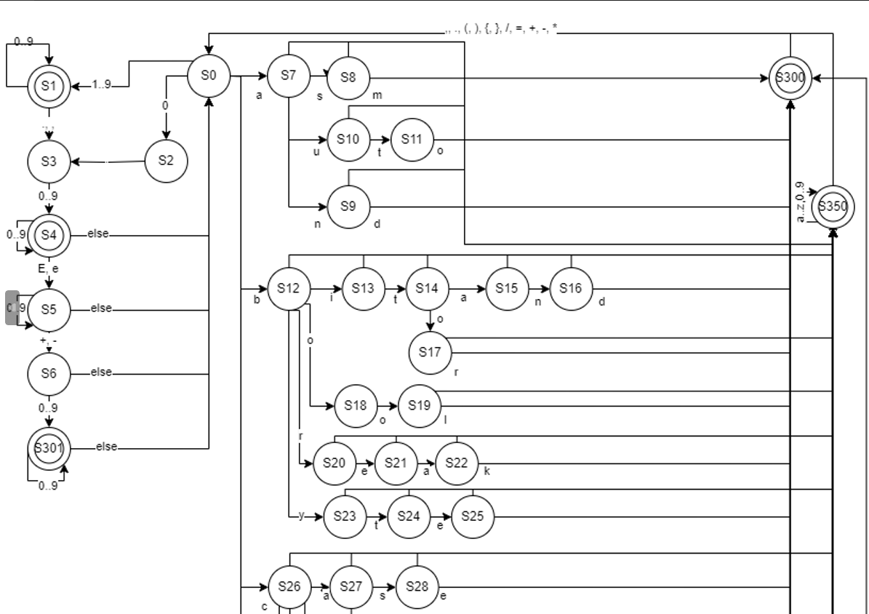

Рис. 1. Граф детерминированного автомата. Часть 1

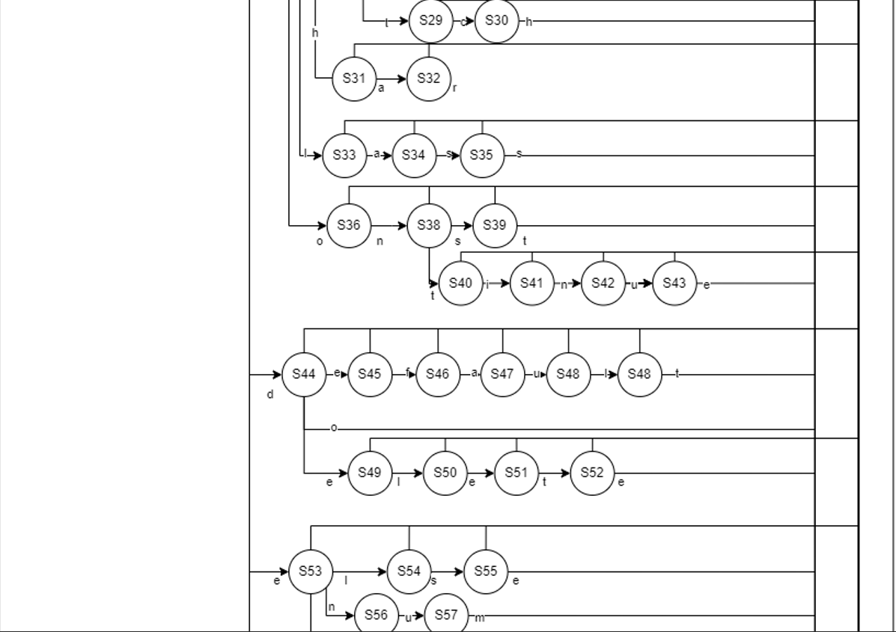

Рис. 2. Граф детерминированного автомата. Часть 2

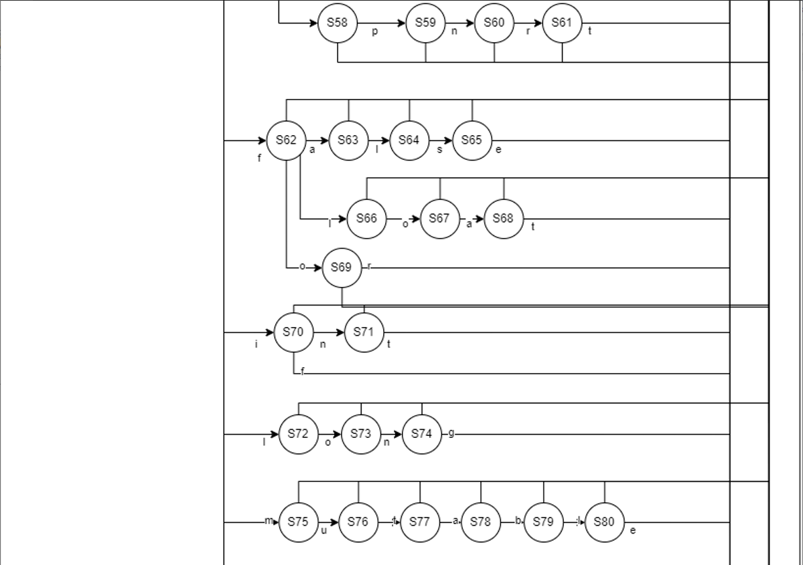

Рис. 3. Граф детерминированного автомата. Часть 3

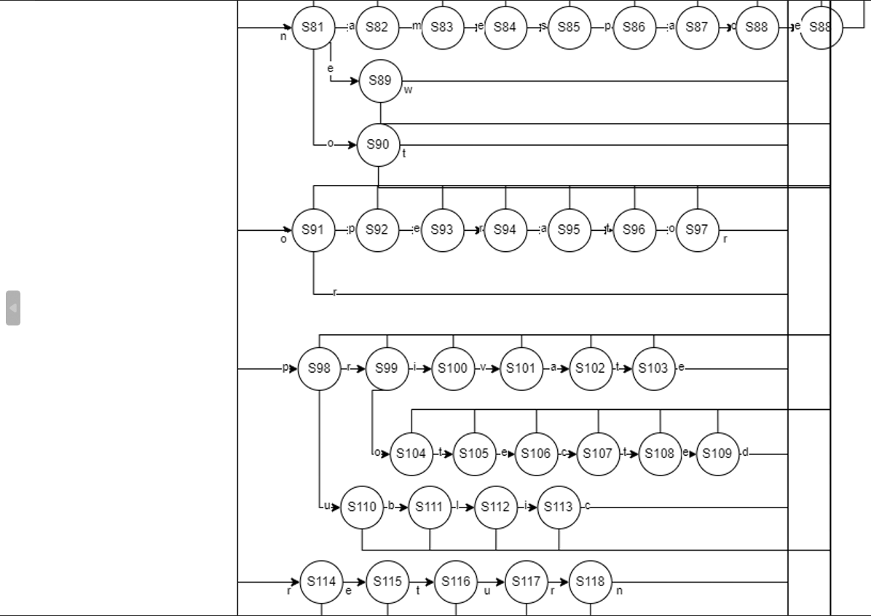

Рис. 4. Граф детерминированного автомата. Часть 4

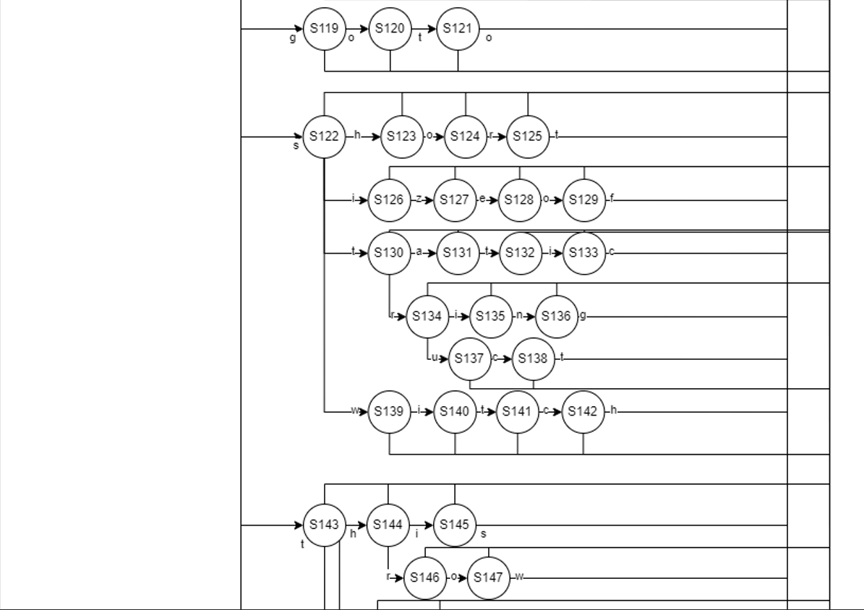

Рис. 5. Граф детерминированного автомата. Часть 5

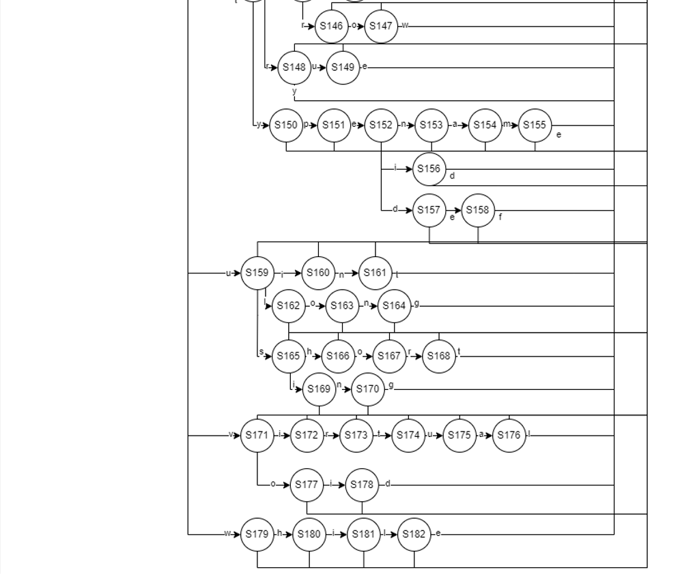

Рис. 6. Граф детерминированного автомата. Часть 6

Блок-схема:

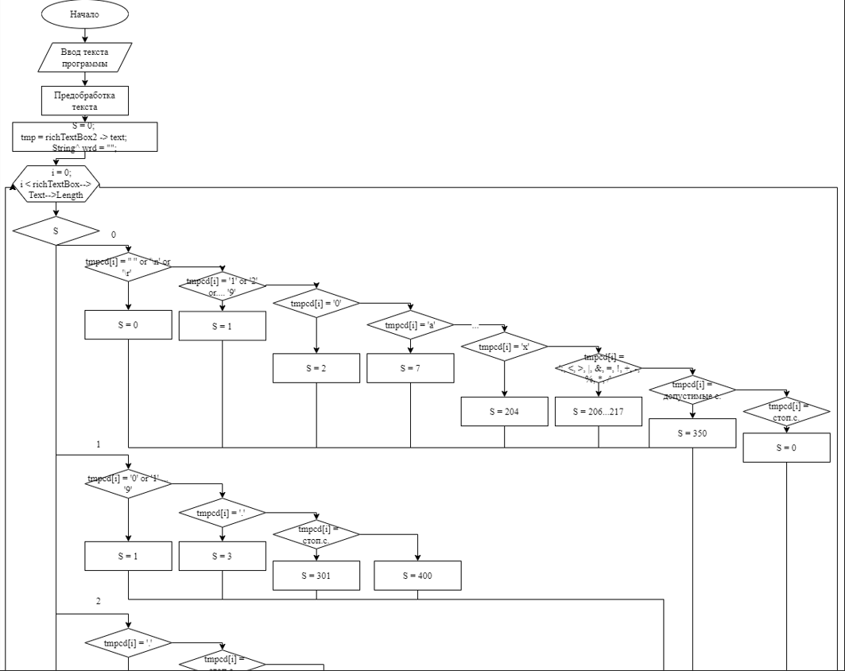

Рис. 5. Блок-схема. Часть 1

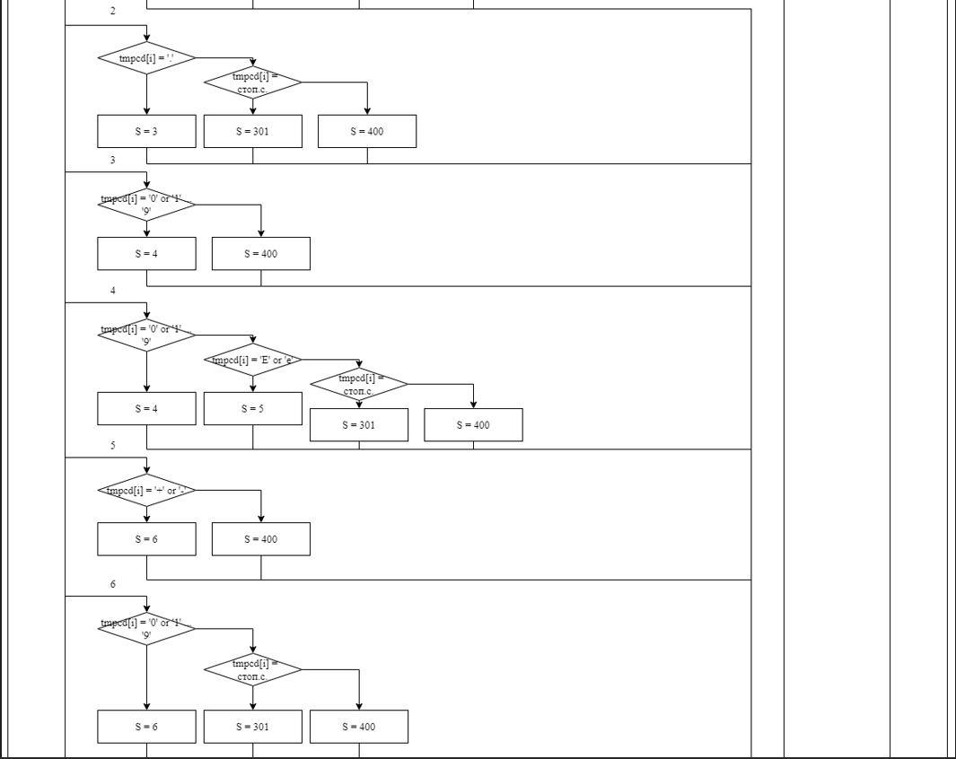

Рис. 6. Блок-схема. Часть 2

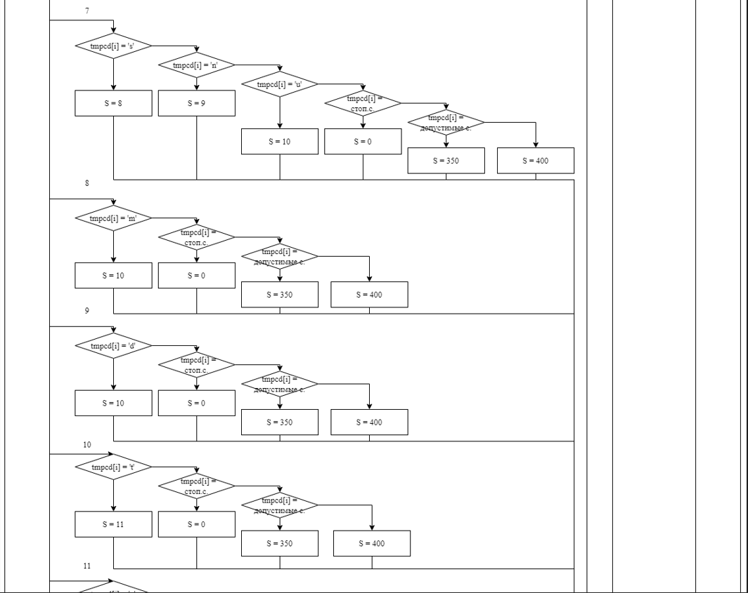

Рис. 7. Блок-схема. Часть 3

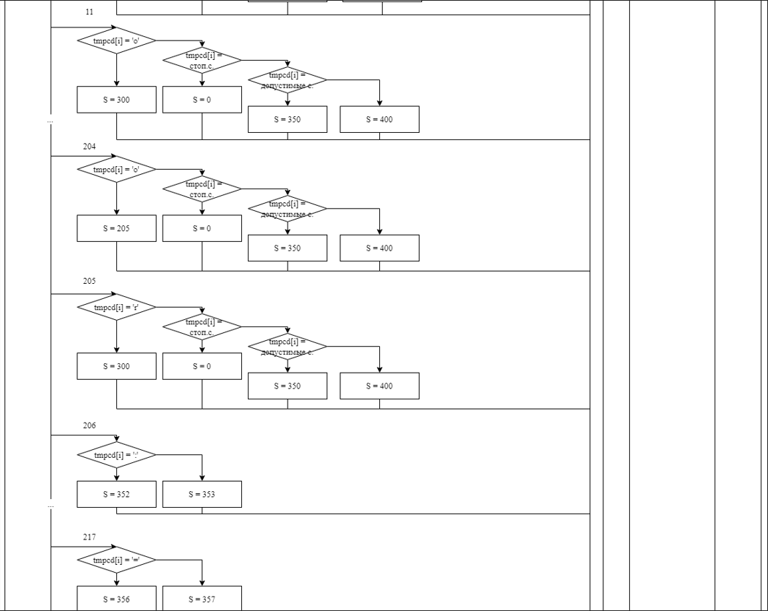

Рис. 8. Блок-схема. Часть 4

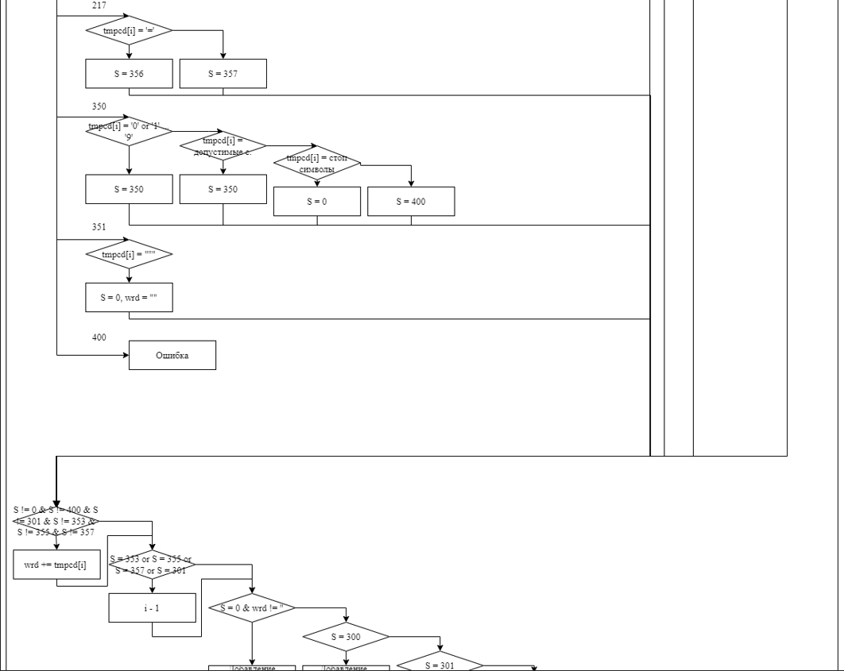

Рис. 9. Блок-схема. Часть 5

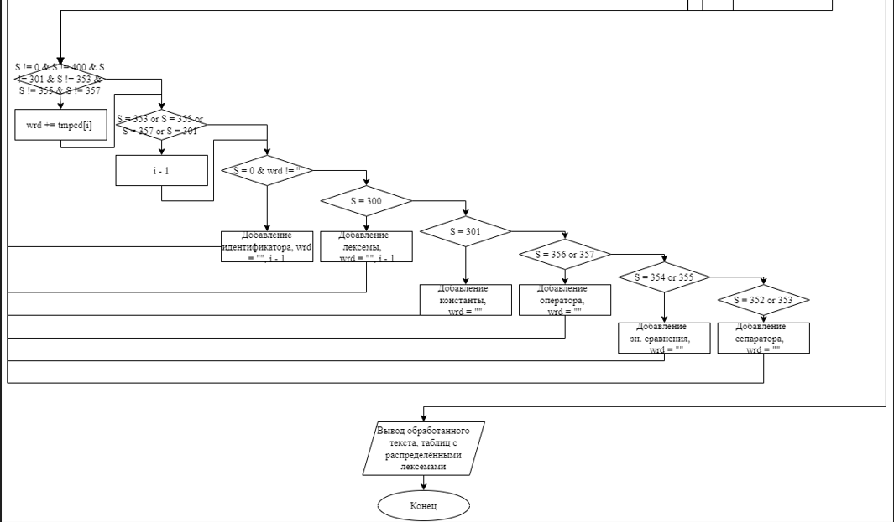

Рис. 10. Блок-схема. Часть 6

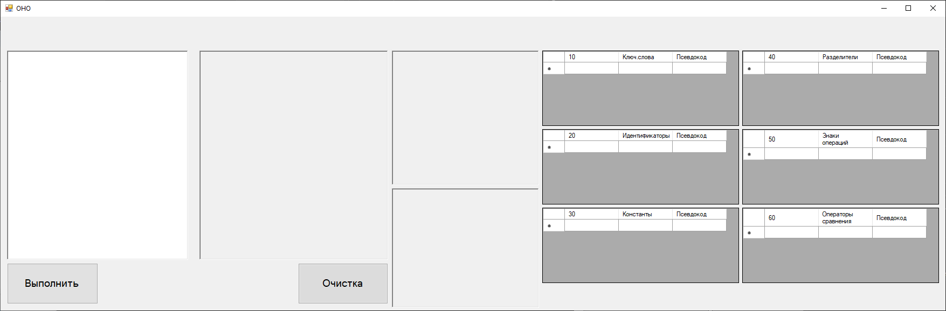

Рис. 11. Интерфейс программы

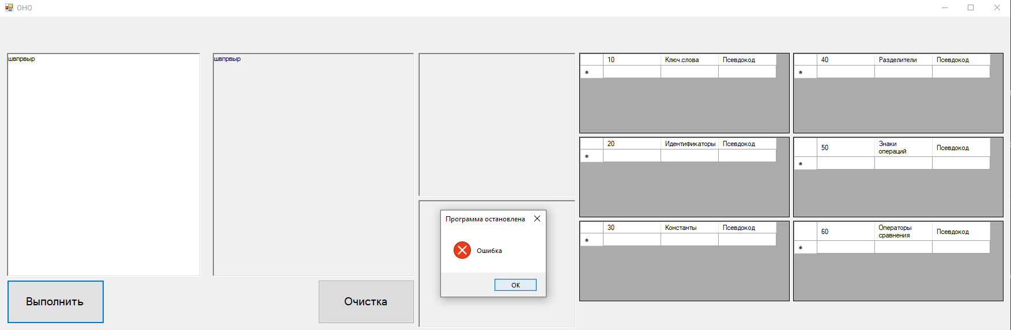

Рис. 11. Ошибка работы программы

Тесты работы программы:

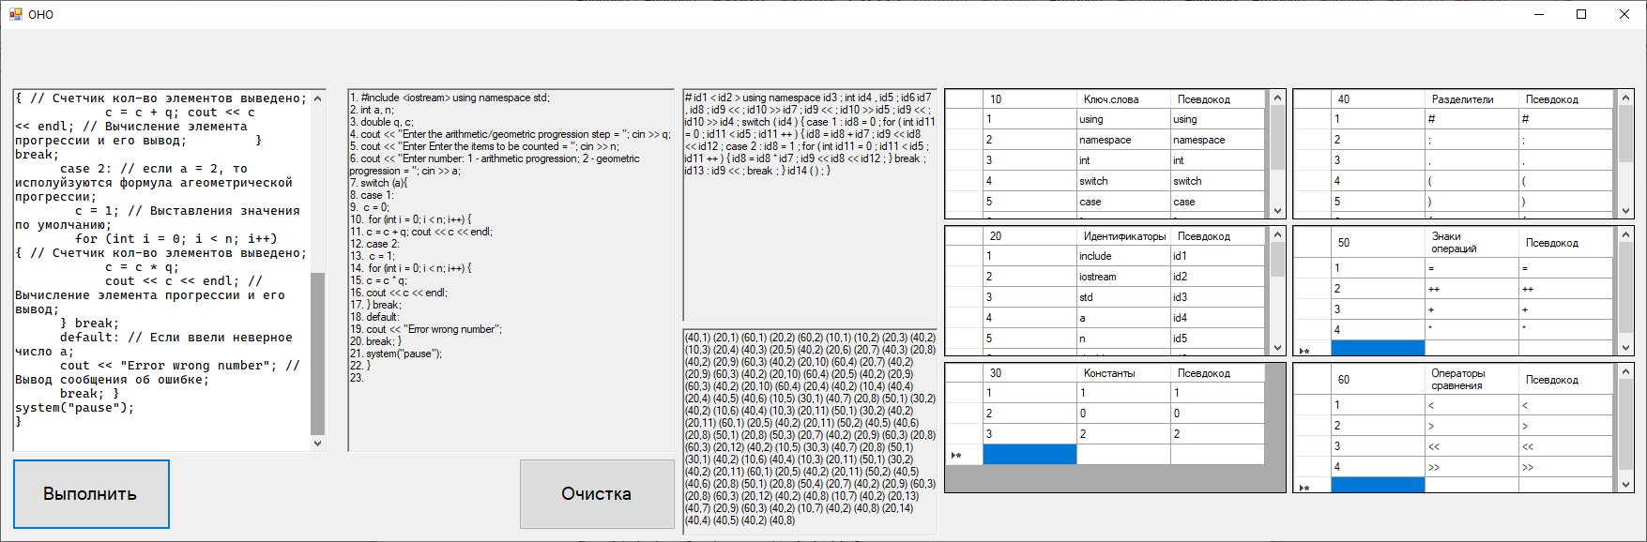

Рис. 12.

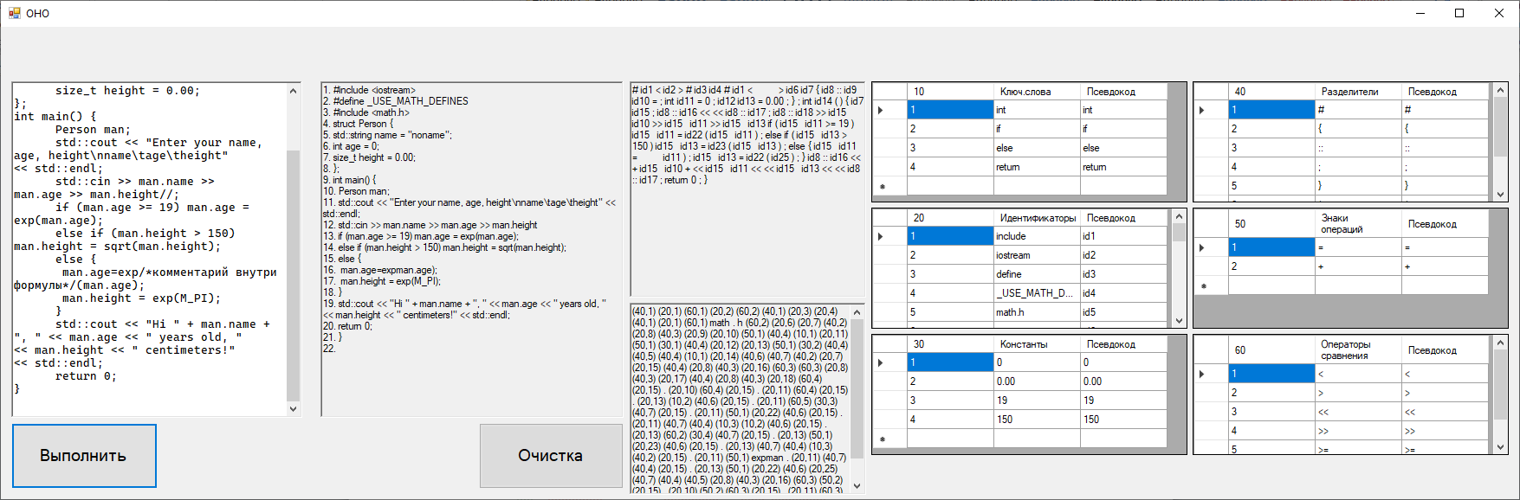

Рис. 13.

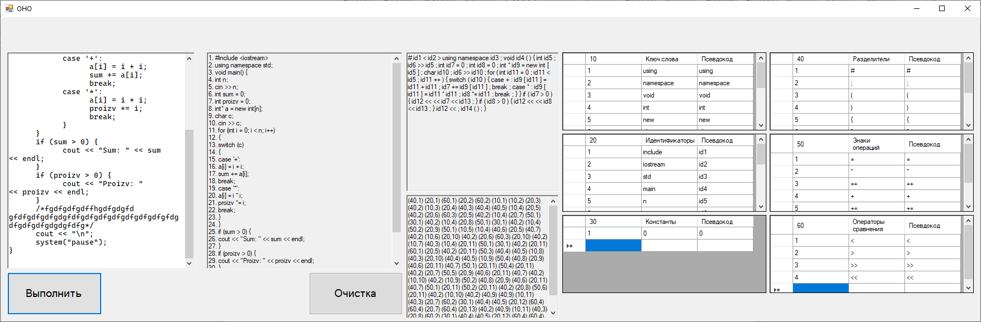

Рис. 14.

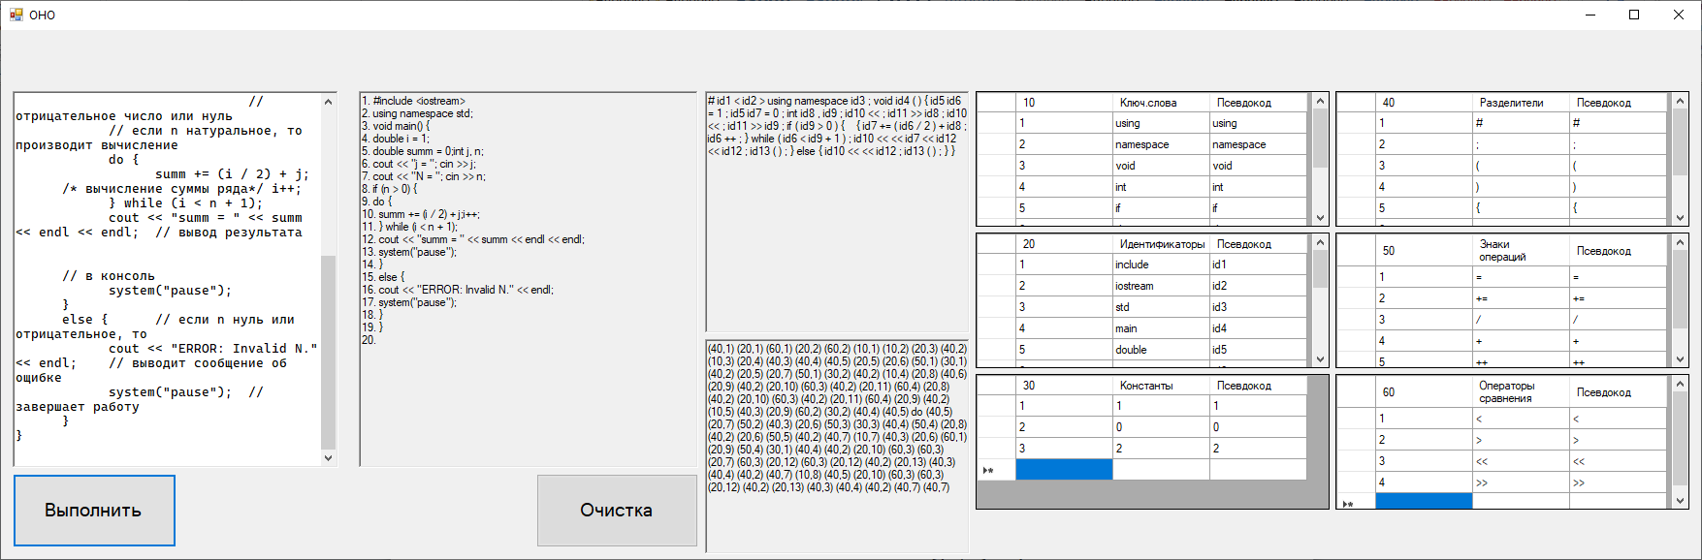

Рис. 15.

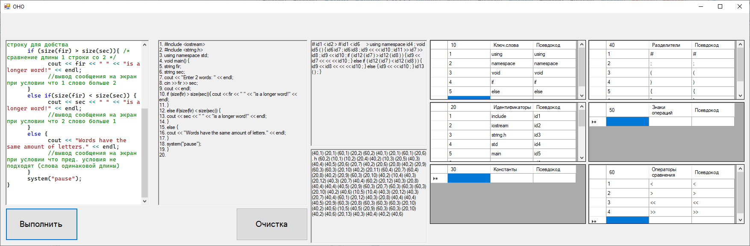

Рис. 15.

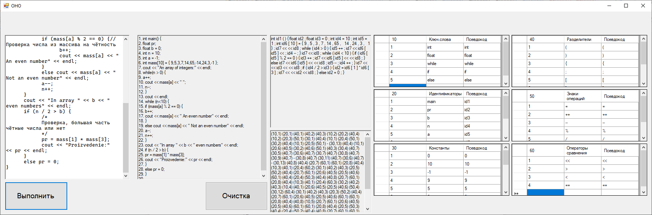

Рис. 15.

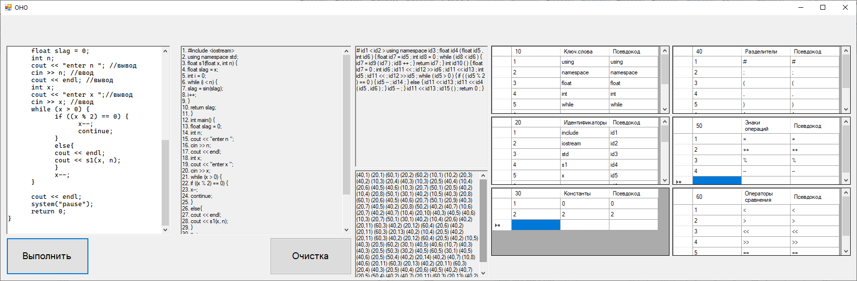

Рис. 15.

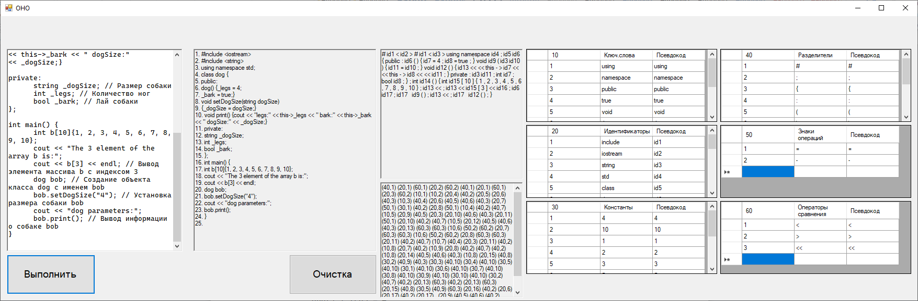

Рис. 15.

Код программы:

#pragma once

#include <string>

namespace A1 {

using namespace std;

using namespace System;

using namespace System::ComponentModel;

using namespace System::Collections;

using namespace System::Windows::Forms;

using namespace System::Data;

using namespace System::Drawing;

/// <summary>

/// Сводка для MyForm

/// </summary>

public ref class MyForm : public System::Windows::Forms::Form

{

public:

MyForm(void)

{

InitializeComponent();

}

private: System::Windows::Forms::Label^ label1;

private: System::Windows::Forms::RichTextBox^ richTextBox1;

private: System::Windows::Forms::RichTextBox^ richTextBox2;

private: System::Windows::Forms::Button^ button1;

private: System::Windows::Forms::Button^ button2;

private:System::ComponentModel::Container^ components;

private: System::Windows::Forms::DataGridView^ t_lexme;

private: System::Windows::Forms::DataGridView^ t_cnst;

private: System::Windows::Forms::DataGridViewTextBoxColumn^ Clex1;

private: System::Windows::Forms::DataGridViewTextBoxColumn^ Clex2;

private: System::Windows::Forms::DataGridViewTextBoxColumn^ Ccnst1;

private: System::Windows::Forms::DataGridViewTextBoxColumn^ Ccnst2;

private: System::Windows::Forms::DataGridView^ t_id;

private: System::Windows::Forms::DataGridViewTextBoxColumn^ Cidet1;

private: System::Windows::Forms::DataGridViewTextBoxColumn^ Cidet2;

private: System::Windows::Forms::DataGridView^ t_op_sings;

private: System::Windows::Forms::DataGridViewTextBoxColumn^ dataGridViewTextBoxColumn1;

private: System::Windows::Forms::DataGridViewTextBoxColumn^ dataGridViewTextBoxColumn2;

private: System::Windows::Forms::DataGridView^ t_op_comp;

private: System::Windows::Forms::DataGridViewTextBoxColumn^ dataGridViewTextBoxColumn3;

private: System::Windows::Forms::DataGridViewTextBoxColumn^ dataGridViewTextBoxColumn4;

private: System::Windows::Forms::DataGridView^ t_sep;

private: System::Windows::Forms::DataGridViewTextBoxColumn^ dataGridViewTextBoxColumn5;

private: System::Windows::Forms::DataGridViewTextBoxColumn^ dataGridViewTextBoxColumn6;

private: System::Windows::Forms::RichTextBox^ pseTextBox3;

private: System::Windows::Forms::RichTextBox^ desTextBox4;

private: System::Windows::Forms::DataGridViewTextBoxColumn^ Clex3;

private: System::Windows::Forms::DataGridViewTextBoxColumn^ Ccnst;

private: System::Windows::Forms::DataGridViewTextBoxColumn^ Cidet;

private: System::Windows::Forms::DataGridViewTextBoxColumn^ Column1;

private: System::Windows::Forms::DataGridViewTextBoxColumn^ Column2;

private: System::Windows::Forms::DataGridViewTextBoxColumn^ Column3;

private: System::Windows::Forms::Label^ label2;

protected:

~MyForm()

{

if (components)

{

delete components;

}

}

private:

bool isnum(wchar_t tmp)

{

return (tmp == '1' || tmp == '2' || tmp == '3' || tmp == '4' || tmp == '5' || tmp == '6' || tmp == '7' || tmp == '8' || tmp == '9') ? true : false;

}

bool skip_sings(wchar_t tmp)

{

return (tmp == ' ' || tmp == '\n' || tmp == '\r') ? true : false;

}

bool op_comp(wchar_t tmp)

{

return (tmp == '<' || tmp == '>' || tmp == '=' || tmp == '!') ? true : false;

}

bool op_sings(wchar_t tmp)

{

return (tmp == '=' || tmp == '-' || tmp == '+' || tmp == '*' || tmp == '/' || tmp == '%' || tmp == '|' || tmp == '&') ? true : false;

}

bool spec_chr(wchar_t tmp)

{

return (tmp == ';' || tmp == '(' || tmp == ')' || tmp == '{' || tmp == '}' || tmp == ':' || tmp == '#' || tmp == ',' || tmp == '[' || tmp == ']' || tmp == '.') ? true : false;

}

bool stop_sing(wchar_t tmp)

{

return (spec_chr(tmp) || op_comp(tmp) || op_sings(tmp) || skip_sings(tmp)) ? true : false;

}

bool allchar(wchar_t tmp)

{

return (tmp == '_' || tmp == 'a' || tmp == 'b' || tmp == 'c' || tmp == 'd' || tmp == 'e' || tmp == 'f' || tmp == 'g' || tmp == 'h' || tmp == 'i' || tmp == 'j' || tmp == 'k' || tmp == 'l' || tmp == 'm'

|| tmp == 'n' || tmp == 'o' || tmp == 'p' || tmp == 'q' || tmp == 'r' || tmp == 's' || tmp == 't' || tmp == 'u' || tmp == 'v' || tmp == 'w' || tmp == 'x' || tmp == 'y' || tmp == 'z' || tmp == 'A'

|| tmp == 'B' || tmp == 'C' || tmp == 'D' || tmp == 'E' || tmp == 'F' || tmp == 'G' || tmp == 'H' || tmp == 'I' || tmp == 'J' || tmp == 'K' || tmp == 'L' || tmp == 'M' || tmp == 'N' || tmp == 'O'

|| tmp == 'P' || tmp == 'Q' || tmp == 'R' || tmp == 'S' || tmp == 'T' || tmp == 'U' || tmp == 'V' || tmp == 'W' || tmp == 'X' || tmp == 'Y' || tmp == 'Z' || isnum(tmp) || tmp == '0') ? true : false;

}

bool search_c(String^ wrd, int rows) {

for (int j = 0; j <= rows - 1; j++) {

if (Convert::ToString(t_cnst->Rows[j]->Cells[1]->Value) == wrd) return true;

}

return false;

}

bool search_l(String^ wrd, int rows) {

for (int j = 0; j <= rows - 1; j++) {

if (Convert::ToString(t_lexme->Rows[j]->Cells[1]->Value) == wrd) return true;

}

return false;

}

bool search_id(String^ wrd, int rows) {

for (int j = 0; j <= rows - 1; j++) {

if (Convert::ToString(t_id->Rows[j]->Cells[1]->Value) == wrd) return true;

}

return false;

}

bool search_op_s(String^ wrd, int rows) {

for (int j = 0; j <= rows - 1; j++) {

if (Convert::ToString(t_op_sings->Rows[j]->Cells[1]->Value) == wrd) return true;

}

return false;

}

bool search_comp(String^ wrd, int rows) {

for (int j = 0; j <= rows - 1; j++) {

if (Convert::ToString(t_op_comp->Rows[j]->Cells[1]->Value) == wrd) return true;

}

return false;

}

bool search_separ(String^ wrd, int rows) {

for (int j = 0; j <= rows - 1; j++) {

if (Convert::ToString(t_sep->Rows[j]->Cells[1]->Value) == wrd) return true;

}

return false;

}

void add_cnst(String^ wrd, int &rows)

{

if (!search_c(wrd, rows)) {

t_cnst->RowCount = rows + 1;

t_cnst->Rows[rows - 1]->Cells[0]->Value = Convert::ToString(rows);

t_cnst->Rows[rows - 1]->Cells[1]->Value = wrd;

t_cnst->Rows[rows - 1]->Cells[2]->Value = wrd;

rows++;

}

}

void add_lex(String^ wrd, int &rows)

{

if (!search_l(wrd, rows)) {

t_lexme->RowCount = rows + 1;

t_lexme->Rows[rows - 1]->Cells[0]->Value = Convert::ToString(rows);

t_lexme->Rows[rows - 1]->Cells[1]->Value = wrd;

t_lexme->Rows[rows - 1]->Cells[2]->Value = wrd;

rows++;

}

}

void add_idet(String^ wrd, int& rows)

{

if (!search_id(wrd, rows)) {

t_id->RowCount = rows + 1;

t_id->Rows[rows - 1]->Cells[0]->Value = Convert::ToString(rows);

t_id->Rows[rows - 1]->Cells[1]->Value = wrd;

t_id->Rows[rows - 1]->Cells[2]->Value = "id" + Convert::ToString(rows);

rows++;

}

}

void add_op_s(String^ wrd, int& rows)

{

if (!search_op_s(wrd, rows)) {

t_op_sings->RowCount = rows + 1;

t_op_sings->Rows[rows - 1]->Cells[0]->Value = Convert::ToString(rows);

t_op_sings->Rows[rows - 1]->Cells[1]->Value = wrd;

t_op_sings->Rows[rows - 1]->Cells[2]->Value = wrd;

rows++;

}

}

void add_comp(String^ wrd, int& rows)

{

if (!search_comp(wrd, rows)) {

t_op_comp->RowCount = rows + 1;

t_op_comp->Rows[rows - 1]->Cells[0]->Value = Convert::ToString(rows);

t_op_comp->Rows[rows - 1]->Cells[1]->Value = wrd;

t_op_comp->Rows[rows - 1]->Cells[2]->Value = wrd;

rows++;

}

}

void add_separ(String^ wrd, int& rows)

{

if (!search_separ(wrd, rows)) {

t_sep->RowCount = rows + 1;

t_sep->Rows[rows - 1]->Cells[0]->Value = Convert::ToString(rows);

t_sep->Rows[rows - 1]->Cells[1]->Value = wrd;

t_sep->Rows[rows - 1]->Cells[2]->Value = wrd;

rows++;

}

}

#pragma region Windows Form Designer generated code

/// <summary>

/// Требуемый метод для поддержки конструктора — не изменяйте

/// содержимое этого метода с помощью редактора кода.

/// </summary>

void InitializeComponent(void)

{

this->label2 = (gcnew System::Windows::Forms::Label());

this->label1 = (gcnew System::Windows::Forms::Label());

this->richTextBox1 = (gcnew System::Windows::Forms::RichTextBox());

this->richTextBox2 = (gcnew System::Windows::Forms::RichTextBox());

this->button1 = (gcnew System::Windows::Forms::Button());

this->button2 = (gcnew System::Windows::Forms::Button());

this->t_lexme = (gcnew System::Windows::Forms::DataGridView());

this->Clex1 = (gcnew System::Windows::Forms::DataGridViewTextBoxColumn());

this->Clex2 = (gcnew System::Windows::Forms::DataGridViewTextBoxColumn());

this->t_cnst = (gcnew System::Windows::Forms::DataGridView());

this->Ccnst1 = (gcnew System::Windows::Forms::DataGridViewTextBoxColumn());

this->Ccnst2 = (gcnew System::Windows::Forms::DataGridViewTextBoxColumn());

this->t_id = (gcnew System::Windows::Forms::DataGridView());

this->Cidet1 = (gcnew System::Windows::Forms::DataGridViewTextBoxColumn());

this->Cidet2 = (gcnew System::Windows::Forms::DataGridViewTextBoxColumn());

this->t_op_sings = (gcnew System::Windows::Forms::DataGridView());

this->dataGridViewTextBoxColumn1 = (gcnew System::Windows::Forms::DataGridViewTextBoxColumn());

this->dataGridViewTextBoxColumn2 = (gcnew System::Windows::Forms::DataGridViewTextBoxColumn());

this->t_op_comp = (gcnew System::Windows::Forms::DataGridView());

this->dataGridViewTextBoxColumn3 = (gcnew System::Windows::Forms::DataGridViewTextBoxColumn());

this->dataGridViewTextBoxColumn4 = (gcnew System::Windows::Forms::DataGridViewTextBoxColumn());

this->t_sep = (gcnew System::Windows::Forms::DataGridView());

this->dataGridViewTextBoxColumn5 = (gcnew System::Windows::Forms::DataGridViewTextBoxColumn());

this->dataGridViewTextBoxColumn6 = (gcnew System::Windows::Forms::DataGridViewTextBoxColumn());

this->pseTextBox3 = (gcnew System::Windows::Forms::RichTextBox());

this->desTextBox4 = (gcnew System::Windows::Forms::RichTextBox());

this->Clex3 = (gcnew System::Windows::Forms::DataGridViewTextBoxColumn());

this->Ccnst = (gcnew System::Windows::Forms::DataGridViewTextBoxColumn());

this->Cidet = (gcnew System::Windows::Forms::DataGridViewTextBoxColumn());

this->Column1 = (gcnew System::Windows::Forms::DataGridViewTextBoxColumn());

this->Column2 = (gcnew System::Windows::Forms::DataGridViewTextBoxColumn());

this->Column3 = (gcnew System::Windows::Forms::DataGridViewTextBoxColumn());

(cli::safe_cast<System::ComponentModel::ISupportInitialize^>(this->t_lexme))->BeginInit();

(cli::safe_cast<System::ComponentModel::ISupportInitialize^>(this->t_cnst))->BeginInit();

(cli::safe_cast<System::ComponentModel::ISupportInitialize^>(this->t_id))->BeginInit();

(cli::safe_cast<System::ComponentModel::ISupportInitialize^>(this->t_op_sings))->BeginInit();

(cli::safe_cast<System::ComponentModel::ISupportInitialize^>(this->t_op_comp))->BeginInit();

(cli::safe_cast<System::ComponentModel::ISupportInitialize^>(this->t_sep))->BeginInit();

this->SuspendLayout();

//

// label2

//

this->label2->AutoSize = true;

this->label2->Font = (gcnew System::Drawing::Font(L"Segoe UI Symbol", 14.25F, System::Drawing::FontStyle::Regular, System::Drawing::GraphicsUnit::Point,

static_cast<System::Byte>(0)));

this->label2->Location = System::Drawing::Point(471, 27);

this->label2->Name = L"label2";

this->label2->Size = System::Drawing::Size(145, 25);

this->label2->TabIndex = 13;

this->label2->Text = L"Готовый текст";

//

// label1

//

this->label1->AutoSize = true;

this->label1->Font = (gcnew System::Drawing::Font(L"Segoe UI Symbol", 14.25F, System::Drawing::FontStyle::Regular, System::Drawing::GraphicsUnit::Point,

static_cast<System::Byte>(0)));

this->label1->Location = System::Drawing::Point(92, 27);

this->label1->Name = L"label1";

this->label1->Size = System::Drawing::Size(158, 25);

this->label1->TabIndex = 14;

this->label1->Text = L"Исходный текст";

//

// richTextBox1

//

this->richTextBox1->Location = System::Drawing::Point(12, 63);

this->richTextBox1->Name = L"richTextBox1";

this->richTextBox1->Size = System::Drawing::Size(336, 389);

this->richTextBox1->TabIndex = 15;

this->richTextBox1->Text = L"";

//

// richTextBox2

//

this->richTextBox2->Location = System::Drawing::Point(369, 63);

this->richTextBox2->Name = L"richTextBox2";

this->richTextBox2->ReadOnly = true;

this->richTextBox2->Size = System::Drawing::Size(350, 389);

this->richTextBox2->TabIndex = 16;

this->richTextBox2->Text = L"";

//

// button1

//

this->button1->Font = (gcnew System::Drawing::Font(L"Segoe UI Symbol", 14.25F, System::Drawing::FontStyle::Regular, System::Drawing::GraphicsUnit::Point,

static_cast<System::Byte>(0)));

this->button1->Location = System::Drawing::Point(12, 458);

this->button1->Name = L"button1";

this->button1->Size = System::Drawing::Size(169, 76);

this->button1->TabIndex = 17;

this->button1->Text = L"Выполнить";

this->button1->UseVisualStyleBackColor = true;

this->button1->Click += gcnew System::EventHandler(this, &MyForm::button1_Click);

//

// button2

//

this->button2->BackColor = System::Drawing::Color::Gainsboro;

this->button2->Font = (gcnew System::Drawing::Font(L"Segoe UI Symbol", 14.25F, System::Drawing::FontStyle::Regular, System::Drawing::GraphicsUnit::Point,

static_cast<System::Byte>(0)));

this->button2->Location = System::Drawing::Point(552, 458);

this->button2->Name = L"button2";

this->button2->Size = System::Drawing::Size(167, 76);

this->button2->TabIndex = 20;

this->button2->Text = L"Очистка";

this->button2->UseVisualStyleBackColor = false;

this->button2->Click += gcnew System::EventHandler(this, &MyForm::button2_Click);

//

// t_lexme

//

this->t_lexme->ColumnHeadersHeightSizeMode = System::Windows::Forms::DataGridViewColumnHeadersHeightSizeMode::AutoSize;

this->t_lexme->Columns->AddRange(gcnew cli::array< System::Windows::Forms::DataGridViewColumn^ >(3) {

this->Clex1, this->Clex2,

this->Clex3

});

this->t_lexme->Location = System::Drawing::Point(1005, 63);

this->t_lexme->Name = L"t_lexme";

this->t_lexme->ReadOnly = true;

this->t_lexme->Size = System::Drawing::Size(365, 140);

this->t_lexme->TabIndex = 21;

//

// Clex1

//

this->Clex1->HeaderText = L"10";

this->Clex1->Name = L"Clex1";

this->Clex1->ReadOnly = true;

//

// Clex2

//

this->Clex2->HeaderText = L"Ключ.слова";

this->Clex2->Name = L"Clex2";

this->Clex2->ReadOnly = true;

//

// t_cnst

//

this->t_cnst->ColumnHeadersHeightSizeMode = System::Windows::Forms::DataGridViewColumnHeadersHeightSizeMode::AutoSize;

this->t_cnst->Columns->AddRange(gcnew cli::array< System::Windows::Forms::DataGridViewColumn^ >(3) {

this->Ccnst1, this->Ccnst2,

this->Ccnst

});

this->t_cnst->Location = System::Drawing::Point(1005, 209);

this->t_cnst->Name = L"t_cnst";

this->t_cnst->ReadOnly = true;

this->t_cnst->Size = System::Drawing::Size(365, 140);

this->t_cnst->TabIndex = 22;

//

// Ccnst1

//

this->Ccnst1->HeaderText = L"20";

this->Ccnst1->Name = L"Ccnst1";

this->Ccnst1->ReadOnly = true;

//

// Ccnst2

//

this->Ccnst2->HeaderText = L"Константы";

this->Ccnst2->Name = L"Ccnst2";

this->Ccnst2->ReadOnly = true;

//

// t_id

//

this->t_id->ColumnHeadersHeightSizeMode = System::Windows::Forms::DataGridViewColumnHeadersHeightSizeMode::AutoSize;

this->t_id->Columns->AddRange(gcnew cli::array< System::Windows::Forms::DataGridViewColumn^ >(3) {

this->Cidet1, this->Cidet2,

this->Cidet

});

this->t_id->Location = System::Drawing::Point(1005, 355);

this->t_id->Name = L"t_id";

this->t_id->Size = System::Drawing::Size(365, 140);

this->t_id->TabIndex = 23;

//

// Cidet1

//

this->Cidet1->HeaderText = L"30";

this->Cidet1->Name = L"Cidet1";

//

// Cidet2

//

this->Cidet2->HeaderText = L"Идентификаторы";

this->Cidet2->Name = L"Cidet2";

//

// t_op_sings

//

this->t_op_sings->ColumnHeadersHeightSizeMode = System::Windows::Forms::DataGridViewColumnHeadersHeightSizeMode::AutoSize;

this->t_op_sings->Columns->AddRange(gcnew cli::array< System::Windows::Forms::DataGridViewColumn^ >(3) {

this->dataGridViewTextBoxColumn1,

this->dataGridViewTextBoxColumn2, this->Column1

});

this->t_op_sings->Location = System::Drawing::Point(1376, 63);

this->t_op_sings->Name = L"t_op_sings";

this->t_op_sings->ReadOnly = true;

this->t_op_sings->Size = System::Drawing::Size(365, 140);

this->t_op_sings->TabIndex = 24;

//

// dataGridViewTextBoxColumn1

//

this->dataGridViewTextBoxColumn1->HeaderText = L"40";

this->dataGridViewTextBoxColumn1->Name = L"dataGridViewTextBoxColumn1";

this->dataGridViewTextBoxColumn1->ReadOnly = true;

//

// dataGridViewTextBoxColumn2

//

this->dataGridViewTextBoxColumn2->HeaderText = L"Знаки операций";

this->dataGridViewTextBoxColumn2->Name = L"dataGridViewTextBoxColumn2";

this->dataGridViewTextBoxColumn2->ReadOnly = true;

//

// t_op_comp

//

this->t_op_comp->ColumnHeadersHeightSizeMode = System::Windows::Forms::DataGridViewColumnHeadersHeightSizeMode::AutoSize;

this->t_op_comp->Columns->AddRange(gcnew cli::array< System::Windows::Forms::DataGridViewColumn^ >(3) {

this->dataGridViewTextBoxColumn3,

this->dataGridViewTextBoxColumn4, this->Column2

});

this->t_op_comp->Location = System::Drawing::Point(1376, 209);

this->t_op_comp->Name = L"t_op_comp";

this->t_op_comp->ReadOnly = true;

this->t_op_comp->Size = System::Drawing::Size(365, 140);

this->t_op_comp->TabIndex = 25;

//

// dataGridViewTextBoxColumn3

//

this->dataGridViewTextBoxColumn3->HeaderText = L"50";

this->dataGridViewTextBoxColumn3->Name = L"dataGridViewTextBoxColumn3";

this->dataGridViewTextBoxColumn3->ReadOnly = true;

//

// dataGridViewTextBoxColumn4

//

this->dataGridViewTextBoxColumn4->HeaderText = L"Операторы сравнения";

this->dataGridViewTextBoxColumn4->Name = L"dataGridViewTextBoxColumn4";

this->dataGridViewTextBoxColumn4->ReadOnly = true;

//

// t_sep

//

this->t_sep->ColumnHeadersHeightSizeMode = System::Windows::Forms::DataGridViewColumnHeadersHeightSizeMode::AutoSize;

this->t_sep->Columns->AddRange(gcnew cli::array< System::Windows::Forms::DataGridViewColumn^ >(3) {

this->dataGridViewTextBoxColumn5,

this->dataGridViewTextBoxColumn6, this->Column3

});

this->t_sep->Location = System::Drawing::Point(1376, 355);

this->t_sep->Name = L"t_sep";

this->t_sep->ReadOnly = true;

this->t_sep->Size = System::Drawing::Size(365, 140);

this->t_sep->TabIndex = 26;

//

// dataGridViewTextBoxColumn5

//

this->dataGridViewTextBoxColumn5->HeaderText = L"60";

this->dataGridViewTextBoxColumn5->Name = L"dataGridViewTextBoxColumn5";

this->dataGridViewTextBoxColumn5->ReadOnly = true;

//

// dataGridViewTextBoxColumn6

//

this->dataGridViewTextBoxColumn6->HeaderText = L"Разделители";

this->dataGridViewTextBoxColumn6->Name = L"dataGridViewTextBoxColumn6";

this->dataGridViewTextBoxColumn6->ReadOnly = true;

//

// pseTextBox3

//

this->pseTextBox3->Location = System::Drawing::Point(726, 63);

this->pseTextBox3->Name = L"pseTextBox3";

this->pseTextBox3->ReadOnly = true;

this->pseTextBox3->Size = System::Drawing::Size(273, 250);

this->pseTextBox3->TabIndex = 27;

this->pseTextBox3->Text = L"";

//

// desTextBox4

//

this->desTextBox4->ImeMode = System::Windows::Forms::ImeMode::NoControl;

this->desTextBox4->Location = System::Drawing::Point(726, 319);

this->desTextBox4->Name = L"desTextBox4";

this->desTextBox4->ReadOnly = true;

this->desTextBox4->Size = System::Drawing::Size(273, 222);

this->desTextBox4->TabIndex = 28;

this->desTextBox4->Text = L"";

//

// Clex3

//

this->Clex3->HeaderText = L"Псевдокод";

this->Clex3->Name = L"Clex3";

this->Clex3->ReadOnly = true;

//

// Ccnst

//

this->Ccnst->HeaderText = L"Псевдокод";

this->Ccnst->Name = L"Ccnst";

this->Ccnst->ReadOnly = true;

//

// Cidet

//

this->Cidet->HeaderText = L"Псевдокод";

this->Cidet->Name = L"Cidet";

//

// Column1

//

this->Column1->HeaderText = L"Псевдокод";

this->Column1->Name = L"Column1";

this->Column1->ReadOnly = true;

//

// Column2

//

this->Column2->HeaderText = L"Псевдокод";

this->Column2->Name = L"Column2";

this->Column2->ReadOnly = true;

//

// Column3

//

this->Column3->HeaderText = L"Псевдокод";

this->Column3->Name = L"Column3";

this->Column3->ReadOnly = true;

//

// MyForm

//

this->AutoScaleDimensions = System::Drawing::SizeF(6, 13);

this->AutoScaleMode = System::Windows::Forms::AutoScaleMode::Font;

this->ClientSize = System::Drawing::Size(1753, 546);

this->Controls->Add(this->desTextBox4);

this->Controls->Add(this->pseTextBox3);

this->Controls->Add(this->t_sep);

this->Controls->Add(this->t_op_comp);

this->Controls->Add(this->t_op_sings);

this->Controls->Add(this->t_id);

this->Controls->Add(this->t_cnst);

this->Controls->Add(this->t_lexme);

this->Controls->Add(this->button2);

this->Controls->Add(this->button1);

this->Controls->Add(this->richTextBox2);

this->Controls->Add(this->richTextBox1);

this->Controls->Add(this->label1);

this->Controls->Add(this->label2);

this->Name = L"MyForm";

this->Text = L"ОНО";

(cli::safe_cast<System::ComponentModel::ISupportInitialize^>(this->t_lexme))->EndInit();

(cli::safe_cast<System::ComponentModel::ISupportInitialize^>(this->t_cnst))->EndInit();

(cli::safe_cast<System::ComponentModel::ISupportInitialize^>(this->t_id))->EndInit();

(cli::safe_cast<System::ComponentModel::ISupportInitialize^>(this->t_op_sings))->EndInit();

(cli::safe_cast<System::ComponentModel::ISupportInitialize^>(this->t_op_comp))->EndInit();

(cli::safe_cast<System::ComponentModel::ISupportInitialize^>(this->t_sep))->EndInit();

this->ResumeLayout(false);

this->PerformLayout();

}

#pragma endregion

public:

int S = 0, a = 0; //S - состояние автомата, a - количество удаленных элементов

int tmpid; //временная переменная для обозначения начального элемента удаления

void prework()

{

String^ tmpcd = richTextBox1->Text; //обрабатываемый программой текстовый массив

for (int i = 0; i < richTextBox1->Text->Length; i++) {

switch (S) {

case 0:

switch (richTextBox1->Text[i]) {

case '/':

S = 2;

break;

case ' ': //пробел

S = 1;

break;

case '\t':

tmpcd = tmpcd->Remove(i - a, 1); //удаление табуляции

a += 1;

break;

case '\n': //перенос

S = 6;

break;

}

break;

case 1:

switch (richTextBox1->Text[i]) {

case ' ': //пробел повторяется вновь

tmpcd = tmpcd->Remove(i - a, 1);

a += 1;

break;

case '/':

S = 2;

break;

default:

S = 0;

break;

}

break;

case 2:

switch (richTextBox1->Text[i]) {

case '/': //второй слэш - однострочный

tmpid = i - 1; //начальный элемент, с которого осуществляется удаление

S = 3;

break;

case '*': //звездочка полсе слэша - начало многострочного

tmpid = i - 1;

S = 4;

break;

default:

S = 0;

break;

}

break;

case 3:

switch (richTextBox1->Text[i]) {

case '\n': //переход на новую строку после однострочного комментария

tmpcd = tmpcd->Remove(tmpid - a, i - tmpid);

a += i - tmpid;

if (tmpid == 0 || tmpcd[i - a - 1] == '\n') {

tmpcd = tmpcd->Remove(i - a, 1);

a += 1;

}

S = 0;

break;

}

break;

case 4:

switch (richTextBox1->Text[i]) {

case '*': //вторая звездочка - многострочный комментарий заканчивается

S = 5;

break;

}

break;

case 5:

switch (richTextBox1->Text[i]) {

case '/': //слэш после звезды - конец многострочного комментария

tmpcd = tmpcd->Remove(tmpid - a, i - tmpid + 2);

a += i - tmpid + 2;

S = 0;

break;

default: //возврат

S = 4;

break;

}

break;

case 6:

switch (richTextBox1->Text[i]) {

case '\n':

tmpcd = tmpcd->Remove(i - a, 1);

a += 1;

break;

case '/':

S = 2;

break;

case '\t': // табуляция

tmpcd = tmpcd->Remove(i - a, 1);

a += 1;

break;

default: // сброс

S = 0;

break;

}

break;

}

}

if (S == 4) {

tmpcd = tmpcd->Remove(tmpid - a, richTextBox1->Text->Length - tmpid);

}

a = 1;

/* for (int i = 0; i < tmpcd->Length; i++) {

if (i == 0) {

tmpcd = tmpcd->Insert(i, a.ToString() + ". ");

a++;

}

if (tmpcd[i] == '\n') {

tmpcd = tmpcd->Insert(i + 1, a.ToString() + ". ");

a++;

}

}*/

richTextBox2->Text = tmpcd;

}

void work(int &lex_rows, int &cnst_rows, int &idet_rows, int &op_rows, int &comp_rows, int &sep_rows)

{

int S = 0, line = 0;

String^ tmpcd = richTextBox2->Text;

String^ tmpwd = "";

for (int i = 0; i < richTextBox2->Text->Length; i++) {

switch (S) {

case 0:

if (skip_sings(tmpcd[i])) S = 0;

else if (isnum(tmpcd[i])) S = 1;

else if (tmpcd[i] == '"') S = 351;

else if (tmpcd[i] == Convert::ToChar("'")) S = 399;

else if (tmpcd[i] == '0') S = 2;

else if (tmpcd[i] == 'a') S = 7;

else if (tmpcd[i] == 'b') S = 12;

else if (tmpcd[i] == 'c') S = 23;

else if (tmpcd[i] == 'd') S = 218;

else if (tmpcd[i] == 'e') S = 50;

else if (tmpcd[i] == 'f') S = 59;

else if (tmpcd[i] == 'i') S = 67;

else if (tmpcd[i] == 'n') S = 73;

else if (tmpcd[i] == 'o') S = 91;

else if (tmpcd[i] == 'p') S = 112;

else if (tmpcd[i] == 'r') S = 128;

else if (tmpcd[i] == 'g') S = 133;

else if (tmpcd[i] == 's') S = 136;

else if (tmpcd[i] == 't') S = 155;

else if (tmpcd[i] == 'u') S = 177;

else if (tmpcd[i] == 'v') S = 181;

else if (tmpcd[i] == 'w') S = 194;

else if (tmpcd[i] == 'm') S = 198;

else if (tmpcd[i] == 'x') S = 204;

else if (tmpcd[i] == '.' || tmpcd[i] == ',' || tmpcd[i] == '{' || tmpcd[i] == '}' || tmpcd[i] == '[' || tmpcd[i] == ']' || tmpcd[i] == '(' || tmpcd[i] == ')' || tmpcd[i] == ';' || tmpcd[i] == '#') S = 352;

else if (tmpcd[i] == ':') S = 206;

else if (tmpcd[i] == '<') S = 207;

else if (tmpcd[i] == '>') S = 208;

else if (tmpcd[i] == '|') S = 209;

else if (tmpcd[i] == '&') S = 210;

else if (tmpcd[i] == '=') S = 211;

else if (tmpcd[i] == '!') S = 212;

else if (tmpcd[i] == '+') S = 213;

else if (tmpcd[i] == '-') S = 214;

else if (tmpcd[i] == '?') S = 357;

else if (tmpcd[i] == '%') S = 215;

else if (tmpcd[i] == '*') S = 216;

else if (tmpcd[i] == '/') S = 217;

else if (allchar(tmpcd[i])) S = 350;

else S = 400;

break;

case 1:

if (isnum(tmpcd[i]) || tmpcd[i] == '0') S = 1;

else if (tmpcd[i] == '.') S = 3;

else if (stop_sing(tmpcd[i])) S = 301;

else S = 400;

break;

case 2:

if (tmpcd[i] == '.') S = 3;

else if (stop_sing(tmpcd[i])) S = 301;

else S = 400;

break;

case 3:

if (isnum(tmpcd[i]) || tmpcd[i] == '0') S = 4;

else S = 400;

break;

case 4:

if (isnum(tmpcd[i]) || tmpcd[i] == '0') S = 4;

else if (tmpcd[i] == 'E' || tmpcd[i] == 'e') S = 5;

else if (stop_sing(tmpcd[i])) S = 301;

else S = 400;

break;

case 5:

if (isnum(tmpcd[i]) || tmpcd[i] == '0') S = 5;

if (tmpcd[i] == '+') S = 6;

else if (tmpcd[i] == '-') S = 6;

else S = 400;

break;

case 6:

if (isnum(tmpcd[i]) || tmpcd[i] == '0') S = 6;

else if (stop_sing(tmpcd[i])) S = 301;

else S = 400;

break;

case 7:

if (tmpcd[i] == 's') S = 8;

if (tmpcd[i] == 'n') S = 9;

if (tmpcd[i] == 'u') S = 10;

else if (stop_sing(tmpcd[i])) S = 0;

else if (allchar(tmpcd[i])) S = 350;

else S = 400;

break;

case 8:

if (tmpcd[i] == 'm') S = 300;

else if (stop_sing(tmpcd[i])) S = 0;

else if (allchar(tmpcd[i])) S = 350;

else S = 400;

break;

case 9:

if (tmpcd[i] == 'd') S = 300;

else if (stop_sing(tmpcd[i])) S = 0;

else if (allchar(tmpcd[i])) S = 350;

else S = 400;

break;

case 10:

if (tmpcd[i] == 't') S = 11;

else if (stop_sing(tmpcd[i])) S = 0;

else if (allchar(tmpcd[i])) S = 350;

else S = 400;

break;

case 11:

if (tmpcd[i] == 'o') S = 300;

else if (stop_sing(tmpcd[i])) S = 0;

else if (allchar(tmpcd[i])) S = 350;

else S = 400;

break;

case 12:

if (tmpcd[i] == 'i') S = 13;

else if (tmpcd[i] == 'o') S = 18;

else if (tmpcd[i] == 'r') S = 20;

else if (stop_sing(tmpcd[i])) S = 0;

else if (allchar(tmpcd[i])) S = 350;

else S = 400;

break;

case 13:

if (tmpcd[i] == 't') S = 14;

else if (stop_sing(tmpcd[i])) S = 0;

else if (allchar(tmpcd[i])) S = 350;

else S = 400;

break;

case 14:

if (tmpcd[i] == 'a') S = 15;

else if (tmpcd[i] == 'o') S = 17;

else if (stop_sing(tmpcd[i])) S = 0;

else if (allchar(tmpcd[i])) S = 350;

else S = 400;

break;

case 15:

if (tmpcd[i] == 'n') S = 16;

else if (stop_sing(tmpcd[i])) S = 0;

else if (allchar(tmpcd[i])) S = 350;

else S = 400;

break;

case 16:

if (tmpcd[i] == 'd') S = 300;

else if (stop_sing(tmpcd[i])) S = 0;

else if (allchar(tmpcd[i])) S = 350;

else S = 400;

break;

case 17:

if (tmpcd[i] == 'r') S = 300;

else if (stop_sing(tmpcd[i])) S = 0;

else if (allchar(tmpcd[i])) S = 350;

else S = 400;

break;

case 18:

if (tmpcd[i] == 'o') S = 19;

else if (stop_sing(tmpcd[i])) S = 0;

else if (allchar(tmpcd[i])) S = 350;

else S = 400;

break;

case 19:

if (tmpcd[i] == 'l') S = 300;

else if (stop_sing(tmpcd[i])) S = 0;

else if (allchar(tmpcd[i])) S = 350;

else S = 400;

break;

case 20:

if (tmpcd[i] == 'e') S = 21;

else if (stop_sing(tmpcd[i])) S = 0;

else if (allchar(tmpcd[i])) S = 350;

else S = 400;

break;

case 21:

if (tmpcd[i] == 'a') S = 22;

else if (stop_sing(tmpcd[i])) S = 0;

else if (allchar(tmpcd[i])) S = 350;

else S = 400;

break;

case 22:

if (tmpcd[i] == 'k') S = 300;

else if (stop_sing(tmpcd[i])) S = 0;

else if (allchar(tmpcd[i])) S = 350;

else S = 400;

break;

case 23:

if (tmpcd[i] == 'a') S = 24;

else if (tmpcd[i] == 'h') S = 28;

else if (stop_sing(tmpcd[i])) S = 0;

else if (allchar(tmpcd[i])) S = 350;

else S = 400;

break;

case 24:

if (tmpcd[i] == 's') S = 25;

else if (tmpcd[i] == 't') S = 26;

else if (tmpcd[i] == 'l') S = 30;

else if (tmpcd[i] == 'o') S = 33;

else if (stop_sing(tmpcd[i])) S = 0;

else if (allchar(tmpcd[i])) S = 350;

else S = 400;

break;

case 25:

if (tmpcd[i] == 'e') S = 300;

else if (stop_sing(tmpcd[i])) S = 0;

else if (allchar(tmpcd[i])) S = 350;

else S = 400;

break;

case 26:

if (tmpcd[i] == 'c') S = 27;

else if (stop_sing(tmpcd[i])) S = 0;

else if (allchar(tmpcd[i])) S = 350;

else S = 400;

break;

case 27:

if (tmpcd[i] == 'h') S = 300;

else if (stop_sing(tmpcd[i])) S = 0;

else if (allchar(tmpcd[i])) S = 350;

else S = 400;

break;

case 28:

if (tmpcd[i] == 'a') S = 29;

else if (stop_sing(tmpcd[i])) S = 0;

else if (allchar(tmpcd[i])) S = 350;

else S = 400;

break;

case 29:

if (tmpcd[i] == 'r') S = 300;

else if (stop_sing(tmpcd[i])) S = 0;

else if (allchar(tmpcd[i])) S = 350;

else S = 400;

break;

case 30:

if (tmpcd[i] == 'a') S = 31;

else if (stop_sing(tmpcd[i])) S = 0;

else if (allchar(tmpcd[i])) S = 350;

else S = 400;

break;

case 31:

if (tmpcd[i] == 's') S = 32;

else if (stop_sing(tmpcd[i])) S = 0;

else if (allchar(tmpcd[i])) S = 350;

else S = 400;

break;

case 32:

if (tmpcd[i] == 's') S = 300;

else if (stop_sing(tmpcd[i])) S = 0;

else if (allchar(tmpcd[i])) S = 350;

else S = 400;

break;

case 33:

if (tmpcd[i] == 'n') S = 34;

else if (stop_sing(tmpcd[i])) S = 0;

else if (allchar(tmpcd[i])) S = 350;

else S = 400;

break;

case 34:

if (tmpcd[i] == 's') S = 35;

else if (tmpcd[i] == 't') S = 36;

else if (stop_sing(tmpcd[i])) S = 0;

else if (allchar(tmpcd[i])) S = 350;

else S = 400;

break;

case 35:

if (tmpcd[i] == 't') S = 300;

else if (stop_sing(tmpcd[i])) S = 0;

else if (allchar(tmpcd[i])) S = 350;

else S = 400;

break;

case 36:

if (tmpcd[i] == 'i') S = 38;

else if (stop_sing(tmpcd[i])) S = 0;

else if (allchar(tmpcd[i])) S = 350;

else S = 400;

break;

case 38:

if (tmpcd[i] == 'n') S = 39;

else if (stop_sing(tmpcd[i])) S = 0;

else if (allchar(tmpcd[i])) S = 350;

else S = 400;

break;

case 39:

if (tmpcd[i] == 'u') S = 40;

else if (stop_sing(tmpcd[i])) S = 0;

else if (allchar(tmpcd[i])) S = 350;

else S = 400;

break;

case 40:

if (tmpcd[i] == 'e') S = 300;

else if (stop_sing(tmpcd[i])) S = 0;

else if (allchar(tmpcd[i])) S = 350;

else S = 400;

break;

case 41:

if (tmpcd[i] == 'e') S = 42;

else if (tmpcd[i] == 'o') S = 300;

else if (stop_sing(tmpcd[i])) S = 0;

else if (allchar(tmpcd[i])) S = 350;

else S = 400;

break;

case 42:

if (tmpcd[i] == 'f') S = 43;

else if (tmpcd[i] == 'l') S = 47;

else if (stop_sing(tmpcd[i])) S = 0;

else if (allchar(tmpcd[i])) S = 350;

else S = 400;

break;

case 43:

if (tmpcd[i] == 'a') S = 44;

else if (stop_sing(tmpcd[i])) S = 0;

else if (allchar(tmpcd[i])) S = 350;

else S = 400;

break;

case 44:

if (tmpcd[i] == 'u') S = 45;

else if (stop_sing(tmpcd[i])) S = 0;

else if (allchar(tmpcd[i])) S = 350;

else S = 400;

break;

case 45:

if (tmpcd[i] == 'l') S = 46;

else if (stop_sing(tmpcd[i])) S = 0;

else if (allchar(tmpcd[i])) S = 350;

else S = 400;

break;

case 46:

if (tmpcd[i] == 't') S = 300;

else if (stop_sing(tmpcd[i])) S = 0;

else if (allchar(tmpcd[i])) S = 350;

else S = 400;

break;

case 47:

if (tmpcd[i] == 'e') S = 48;

else if (stop_sing(tmpcd[i])) S = 0;

else if (allchar(tmpcd[i])) S = 350;

else S = 400;

break;

case 48:

if (tmpcd[i] == 't') S = 49;

else if (stop_sing(tmpcd[i])) S = 0;

else if (allchar(tmpcd[i])) S = 350;

else S = 400;

break;

case 49:

if (tmpcd[i] == 'e') S = 300;

else if (stop_sing(tmpcd[i])) S = 0;

else if (allchar(tmpcd[i])) S = 350;

else S = 400;

break;

case 50:

if (tmpcd[i] == 'l') S = 51;

else if (tmpcd[i] == 'n') S = 53;

else if (tmpcd[i] == 'x') S = 55;

else if (stop_sing(tmpcd[i])) S = 0;

else if (allchar(tmpcd[i])) S = 350;

else S = 400;

break;

case 51:

if (tmpcd[i] == 's') S = 52;

else if (stop_sing(tmpcd[i])) S = 0;

else if (allchar(tmpcd[i])) S = 350;

else S = 400;

break;

case 52:

if (tmpcd[i] == 'e') S = 300;

else if (stop_sing(tmpcd[i])) S = 0;

else if (allchar(tmpcd[i])) S = 350;

else S = 400;

break;

case 53:

if (tmpcd[i] == 'u') S = 54;

else if (stop_sing(tmpcd[i])) S = 0;

else if (allchar(tmpcd[i])) S = 350;

else S = 400;

break;

case 54:

if (tmpcd[i] == 'm') S = 300;

else if (stop_sing(tmpcd[i])) S = 0;

else if (allchar(tmpcd[i])) S = 350;

else S = 400;

break;

case 55:

if (tmpcd[i] == 'p') S = 56;

else if (stop_sing(tmpcd[i])) S = 0;

else if (allchar(tmpcd[i])) S = 350;

else S = 400;

break;

case 56:

if (tmpcd[i] == 'o') S = 57;

else if (stop_sing(tmpcd[i])) S = 0;

else if (allchar(tmpcd[i])) S = 350;

else S = 400;

break;

case 57:

if (tmpcd[i] == 'r') S = 58;

else if (stop_sing(tmpcd[i])) S = 0;

else if (allchar(tmpcd[i])) S = 350;

else S = 400;

break;

case 58:

if (tmpcd[i] == 't') S = 300;

else if (stop_sing(tmpcd[i])) S = 0;

else if (allchar(tmpcd[i])) S = 350;

else S = 400;

break;

case 59:

if (tmpcd[i] == 'a') S = 60;

else if (tmpcd[i] == 'l') S = 63;

else if (tmpcd[i] == 'o') S = 66;

else if (tmpcd[i] == 'r') S = 102;

else if (stop_sing(tmpcd[i])) S = 0;

else if (allchar(tmpcd[i])) S = 350;

else S = 400;

break;

case 60:

if (tmpcd[i] == 'l') S = 61;

else if (stop_sing(tmpcd[i])) S = 0;

else if (allchar(tmpcd[i])) S = 350;

else S = 400;

break;

case 61:

if (tmpcd[i] == 's') S = 62;

else if (stop_sing(tmpcd[i])) S = 0;

else if (allchar(tmpcd[i])) S = 350;

else S = 400;

break;

case 62:

if (tmpcd[i] == 'e') S = 300;

else if (stop_sing(tmpcd[i])) S = 0;

else if (allchar(tmpcd[i])) S = 350;

else S = 400;

break;

case 63:

if (tmpcd[i] == 'o') S = 64;

else if (stop_sing(tmpcd[i])) S = 0;

else if (allchar(tmpcd[i])) S = 350;

else S = 400;

break;

case 64:

if (tmpcd[i] == 'a') S = 65;

else if (stop_sing(tmpcd[i])) S = 0;

else if (allchar(tmpcd[i])) S = 350;

else S = 400;

break;

case 65:

if (tmpcd[i] == 't') S = 300;

else if (stop_sing(tmpcd[i])) S = 0;

else if (allchar(tmpcd[i])) S = 350;

else S = 400;

break;

case 66:

if (tmpcd[i] == 'r') S = 300;

else if (stop_sing(tmpcd[i])) S = 0;

else if (allchar(tmpcd[i])) S = 350;

else S = 400;

break;

case 67:

if (tmpcd[i] == 'f') S = 300;

else if (tmpcd[i] == 'n') S = 68;

else if (stop_sing(tmpcd[i])) S = 0;

else if (allchar(tmpcd[i])) S = 350;

else S = 400;

break;

case 68:

if (tmpcd[i] == 't') S = 300;

else if (tmpcd[i] == 'l') S = 99;

else if (stop_sing(tmpcd[i])) S = 0;

else if (allchar(tmpcd[i])) S = 350;

else S = 400;

break;

case 69:

if (tmpcd[i] == 'o') S = 70;

else if (stop_sing(tmpcd[i])) S = 0;

else if (allchar(tmpcd[i])) S = 350;

else S = 400;

break;

case 70:

if (tmpcd[i] == 'o') S = 71;

else if (stop_sing(tmpcd[i])) S = 0;

else if (allchar(tmpcd[i])) S = 350;

else S = 400;

break;

case 71:

if (tmpcd[i] == 'n') S = 72;

else if (stop_sing(tmpcd[i])) S = 0;

else if (allchar(tmpcd[i])) S = 350;

else S = 400;

break;

case 72:

if (tmpcd[i] == 'g') S = 300;

else if (stop_sing(tmpcd[i])) S = 0;

else if (allchar(tmpcd[i])) S = 350;

else S = 400;

break;

case 73:

if (tmpcd[i] == 'a') S = 74;

else if (tmpcd[i] == 'e') S = 81;

else if (tmpcd[i] == 'o') S = 82;

else if (stop_sing(tmpcd[i])) S = 0;

else if (allchar(tmpcd[i])) S = 350;

else S = 400;

break;

case 74:

if (tmpcd[i] == 'm') S = 75;

else if (stop_sing(tmpcd[i])) S = 0;

else if (allchar(tmpcd[i])) S = 350;

else S = 400;

break;

case 75:

if (tmpcd[i] == 'e') S = 76;

else if (stop_sing(tmpcd[i])) S = 0;

else if (allchar(tmpcd[i])) S = 350;

else S = 400;

break;

case 76:

if (tmpcd[i] == 's') S = 77;

else if (stop_sing(tmpcd[i])) S = 0;

else if (allchar(tmpcd[i])) S = 350;

else S = 400;

break;

case 77:

if (tmpcd[i] == 'p') S = 78;

else if (stop_sing(tmpcd[i])) S = 0;

else if (allchar(tmpcd[i])) S = 350;

else S = 400;

break;

case 78:

if (tmpcd[i] == 'a') S = 79;

else if (stop_sing(tmpcd[i])) S = 0;

else if (allchar(tmpcd[i])) S = 350;

else S = 400;

break;

case 79:

if (tmpcd[i] == 'c') S = 80;

else if (stop_sing(tmpcd[i])) S = 0;

else if (allchar(tmpcd[i])) S = 350;

else S = 400;

break;

case 80:

if (tmpcd[i] == 'e') S = 300;

else if (stop_sing(tmpcd[i])) S = 0;

else if (allchar(tmpcd[i])) S = 350;

else S = 400;

break;

case 81:

if (tmpcd[i] == 'w') S = 300;

else if (stop_sing(tmpcd[i])) S = 0;

else if (allchar(tmpcd[i])) S = 350;

else S = 400;

break;

case 82:

if (allchar(tmpcd[i + 1]) && tmpcd[i] == 't') S = 83;

else if (!allchar(tmpcd[i + 1]) && tmpcd[i] == 't') S = 300;

else if (stop_sing(tmpcd[i])) S = 0;

else if (allchar(tmpcd[i])) S = 350;

else S = 400;

break;

case 83:

if (tmpcd[i] == 'e') S = 84;

else if (tmpcd[i] == '_') S = 89;

else if (stop_sing(tmpcd[i])) S = 0;

else if (allchar(tmpcd[i])) S = 350;

else S = 400;

case 84:

if (tmpcd[i] == 'x') S = 85;

else if (stop_sing(tmpcd[i])) S = 0;

else if (allchar(tmpcd[i])) S = 350;

else S = 400;

break;

case 85:

if (tmpcd[i] == 'p') S = 86;

else if (stop_sing(tmpcd[i])) S = 0;

else if (allchar(tmpcd[i])) S = 350;

else S = 400;

break;

case 86:

if (tmpcd[i] == 'e') S = 87;

else if (stop_sing(tmpcd[i])) S = 0;

else if (allchar(tmpcd[i])) S = 350;

else S = 400;

break;

case 87:

if (tmpcd[i] == 'c') S = 88;

else if (stop_sing(tmpcd[i])) S = 0;

else if (allchar(tmpcd[i])) S = 350;

else S = 400;

break;

case 88:

if (tmpcd[i] == 't') S = 300;

else if (stop_sing(tmpcd[i])) S = 0;

else if (allchar(tmpcd[i])) S = 350;

else S = 400;

break;

case 89:

if (tmpcd[i] == 'e') S = 90;

else if (stop_sing(tmpcd[i])) S = 0;

else if (allchar(tmpcd[i])) S = 350;

else S = 400;

break;

case 90:

if (tmpcd[i] == 'q') S = 300;

else if (stop_sing(tmpcd[i])) S = 0;

else if (allchar(tmpcd[i])) S = 350;

else S = 400;

break;

case 91:

if (tmpcd[i] == 'p') S = 92;

else if (tmpcd[i] == 'r') S = 300;

else if (stop_sing(tmpcd[i])) S = 0;

else if (allchar(tmpcd[i])) S = 350;

else S = 400;

break;

case 92:

if (tmpcd[i] == 'e') S = 93;

else if (stop_sing(tmpcd[i])) S = 0;

else if (allchar(tmpcd[i])) S = 350;

else S = 400;

break;

case 93:

if (tmpcd[i] == 'r') S = 94;

else if (stop_sing(tmpcd[i])) S = 0;

else if (allchar(tmpcd[i])) S = 350;

else S = 400;

break;

case 94:

if (tmpcd[i] == 'a') S = 95;

else if (stop_sing(tmpcd[i])) S = 0;

else if (allchar(tmpcd[i])) S = 350;

else S = 400;

break;

case 95:

if (tmpcd[i] == 't') S = 96;

else if (stop_sing(tmpcd[i])) S = 0;

else if (allchar(tmpcd[i])) S = 350;

else S = 400;

break;

case 96:

if (tmpcd[i] == 'o') S = 97;

else if (stop_sing(tmpcd[i])) S = 0;

else if (allchar(tmpcd[i])) S = 350;

else S = 400;

break;

case 98:

if (tmpcd[i] == 'r') S = 300;

else if (stop_sing(tmpcd[i])) S = 0;

else if (allchar(tmpcd[i])) S = 350;

else S = 400;

break;

case 99:

if (tmpcd[i] == 'i') S = 100;

else if (stop_sing(tmpcd[i])) S = 0;

else if (allchar(tmpcd[i])) S = 350;

else S = 400;

break;

case 100:

if (tmpcd[i] == 'n') S = 101;

else if (stop_sing(tmpcd[i])) S = 0;

else if (allchar(tmpcd[i])) S = 350;

else S = 400;

break;

case 101:

if (tmpcd[i] == 'e') S = 300;

else if (stop_sing(tmpcd[i])) S = 0;

else if (allchar(tmpcd[i])) S = 350;

else S = 400;

break;

case 102:

if (tmpcd[i] == 'i') S = 103;

else if (stop_sing(tmpcd[i])) S = 0;

else if (allchar(tmpcd[i])) S = 350;

else S = 400;

break;

case 103:

if (tmpcd[i] == 'e') S = 104;

else if (stop_sing(tmpcd[i])) S = 0;

else if (allchar(tmpcd[i])) S = 350;

else S = 400;

break;

case 104:

if (tmpcd[i] == 'n') S = 105;

else if (stop_sing(tmpcd[i])) S = 0;

else if (allchar(tmpcd[i])) S = 350;

else S = 400;

break;

case 105:

if (tmpcd[i] == 'd') S = 300;

else if (stop_sing(tmpcd[i])) S = 0;

else if (allchar(tmpcd[i])) S = 350;

else S = 400;

break;

case 106:

if (tmpcd[i] == 'u') S = 107;

else if (stop_sing(tmpcd[i])) S = 0;

else if (allchar(tmpcd[i])) S = 350;

else S = 400;

break;

case 107:

if (tmpcd[i] == 'l') S = 108;

else if (stop_sing(tmpcd[i])) S = 0;

else if (allchar(tmpcd[i])) S = 350;

else S = 400;

break;

case 108:

if (tmpcd[i] == 'l') S = 109;

else if (stop_sing(tmpcd[i])) S = 0;

else if (allchar(tmpcd[i])) S = 350;

else S = 400;

break;

case 109:

if (tmpcd[i] == 'p') S = 110;

else if (stop_sing(tmpcd[i])) S = 0;

else if (allchar(tmpcd[i])) S = 350;

else S = 400;

break;

case 110:

if (tmpcd[i] == 't') S = 111;

else if (stop_sing(tmpcd[i])) S = 0;

else if (allchar(tmpcd[i])) S = 350;

else S = 400;

break;

case 111:

if (tmpcd[i] == 'r') S = 300;

else if (stop_sing(tmpcd[i])) S = 0;

else if (allchar(tmpcd[i])) S = 350;

else S = 400;

break;

case 112:

if (tmpcd[i] == 'r') S = 113;

else if (tmpcd[i] == 'u') S = 124;

else if (stop_sing(tmpcd[i])) S = 0;

else if (allchar(tmpcd[i])) S = 350;

else S = 400;

break;

case 113:

if (tmpcd[i] == 'i') S = 114;

else if (tmpcd[i] == 'o') S = 118;

else if (stop_sing(tmpcd[i])) S = 0;

else if (allchar(tmpcd[i])) S = 350;

else S = 400;

break;

case 114:

if (tmpcd[i] == 'v') S = 115;

else if (stop_sing(tmpcd[i])) S = 0;

else if (allchar(tmpcd[i])) S = 350;

else S = 400;

break;

case 115:

if (tmpcd[i] == 'a') S = 116;

else if (stop_sing(tmpcd[i])) S = 0;

else if (allchar(tmpcd[i])) S = 350;

else S = 400;

break;

case 116:

if (tmpcd[i] == 't') S = 117;

else if (stop_sing(tmpcd[i])) S = 0;

else if (allchar(tmpcd[i])) S = 350;

else S = 400;

break;

case 117:

if (tmpcd[i] == 'e') S = 300;

else if (stop_sing(tmpcd[i])) S = 0;

else if (allchar(tmpcd[i])) S = 350;

else S = 400;

break;

case 118:

if (tmpcd[i] == 't') S = 119;

else if (stop_sing(tmpcd[i])) S = 0;

else if (allchar(tmpcd[i])) S = 350;

else S = 400;

break;

case 119:

if (tmpcd[i] == 'e') S = 120;

else if (stop_sing(tmpcd[i])) S = 0;

else if (allchar(tmpcd[i])) S = 350;

else S = 400;

break;

case 120:

if (tmpcd[i] == 'c') S = 121;

else if (stop_sing(tmpcd[i])) S = 0;

else if (allchar(tmpcd[i])) S = 350;

else S = 400;

break;

case 121:

if (tmpcd[i] == 't') S = 122;

else if (stop_sing(tmpcd[i])) S = 0;

else if (allchar(tmpcd[i])) S = 350;

else S = 400;

break;

case 122:

if (tmpcd[i] == 'e') S = 123;

else if (stop_sing(tmpcd[i])) S = 0;

else if (allchar(tmpcd[i])) S = 350;

else S = 400;

break;

case 123:

if (tmpcd[i] == 'd') S = 300;

else if (stop_sing(tmpcd[i])) S = 0;

else if (allchar(tmpcd[i])) S = 350;

else S = 400;

break;

case 124:

if (tmpcd[i] == 'b') S = 125;

else if (stop_sing(tmpcd[i])) S = 0;

else if (allchar(tmpcd[i])) S = 350;

else S = 400;

break;

case 125:

if (tmpcd[i] == 'l') S = 126;

else if (stop_sing(tmpcd[i])) S = 0;

else if (allchar(tmpcd[i])) S = 350;

else S = 400;

break;

case 126:

if (tmpcd[i] == 'i') S = 127;

else if (stop_sing(tmpcd[i])) S = 0;

else if (allchar(tmpcd[i])) S = 350;

else S = 400;

break;

case 127:

if (tmpcd[i] == 'c') S = 300;

else if (stop_sing(tmpcd[i])) S = 0;

else if (allchar(tmpcd[i])) S = 350;

else S = 400;

break;

case 128:

if (tmpcd[i] == 'e') S = 129;

else if (stop_sing(tmpcd[i])) S = 0;

else if (allchar(tmpcd[i])) S = 350;

else S = 400;

break;

case 129:

if (tmpcd[i] == 't') S = 130;

else if (stop_sing(tmpcd[i])) S = 0;

else if (allchar(tmpcd[i])) S = 350;

else S = 400;

break;

case 130:

if (tmpcd[i] == 'u') S = 131;

else if (stop_sing(tmpcd[i])) S = 0;

else if (allchar(tmpcd[i])) S = 350;

else S = 400;

break;

case 131:

if (tmpcd[i] == 'r') S = 132;

else if (stop_sing(tmpcd[i])) S = 0;

else if (allchar(tmpcd[i])) S = 350;

else S = 400;

break;

case 132:

if (tmpcd[i] == 'n') S = 300;

else if (stop_sing(tmpcd[i])) S = 0;

else if (allchar(tmpcd[i])) S = 350;

else S = 400;

break;

case 133:

if (tmpcd[i] == 'o') S = 134;

else if (stop_sing(tmpcd[i])) S = 0;

else if (allchar(tmpcd[i])) S = 350;

else S = 400;

break;

case 134:

if (tmpcd[i] == 't') S = 135;

else if (stop_sing(tmpcd[i])) S = 0;

else if (allchar(tmpcd[i])) S = 350;

else S = 400;

break;

case 135:

if (tmpcd[i] == 'o') S = 300;

else if (stop_sing(tmpcd[i])) S = 0;

else if (allchar(tmpcd[i])) S = 350;

else S = 400;

break;

case 136:

if (tmpcd[i] == 'h') S = 137;

else if (tmpcd[i] == 'i') S = 140;

else if (tmpcd[i] == 't') S = 140;

else if (tmpcd[i] == 'w') S = 151;

else if (stop_sing(tmpcd[i])) S = 0;

else if (allchar(tmpcd[i])) S = 350;

else S = 400;

break;

case 137:

if (tmpcd[i] == 'o') S = 138;

else if (stop_sing(tmpcd[i])) S = 0;

else if (allchar(tmpcd[i])) S = 350;

else S = 400;

break;

case 138:

if (tmpcd[i] == 'r') S = 139;

else if (stop_sing(tmpcd[i])) S = 0;

else if (allchar(tmpcd[i])) S = 350;

else S = 400;

break;

case 139:

if (tmpcd[i] == 't') S = 300;

else if (stop_sing(tmpcd[i])) S = 0;

else if (allchar(tmpcd[i])) S = 350;

else S = 400;

break;

case 140:

if (tmpcd[i] == 'z') S = 141;

else if (stop_sing(tmpcd[i])) S = 0;

else if (allchar(tmpcd[i])) S = 350;

else S = 400;

break;

case 141:

if (tmpcd[i] == 'e') S = 142;

else if (stop_sing(tmpcd[i])) S = 0;

else if (allchar(tmpcd[i])) S = 350;

else S = 400;

break;

case 142:

if (tmpcd[i] == 'o') S = 143;

else if (stop_sing(tmpcd[i])) S = 0;

else if (allchar(tmpcd[i])) S = 350;

else S = 400;

break;

case 143:

if (tmpcd[i] == 'f') S = 300;

else if (stop_sing(tmpcd[i])) S = 0;

else if (allchar(tmpcd[i])) S = 350;

else S = 400;

break;

case 144:

if (tmpcd[i] == 'a') S = 145;

else if (tmpcd[i] == 'r') S = 148;

else if (stop_sing(tmpcd[i])) S = 0;

else if (allchar(tmpcd[i])) S = 350;

else S = 400;

break;

case 145:

if (tmpcd[i] == 't') S = 146;

else if (stop_sing(tmpcd[i])) S = 0;

else if (allchar(tmpcd[i])) S = 350;

else S = 400;

break;

case 146:

if (tmpcd[i] == 'i') S = 147;

else if (stop_sing(tmpcd[i])) S = 0;

else if (allchar(tmpcd[i])) S = 350;

else S = 400;

break;

case 147:

if (tmpcd[i] == 'c') S = 300;

else if (stop_sing(tmpcd[i])) S = 0;

else if (allchar(tmpcd[i])) S = 350;

else S = 400;

break;

case 148:

if (tmpcd[i] == 'u') S = 149;

else if (stop_sing(tmpcd[i])) S = 0;

else if (allchar(tmpcd[i])) S = 350;

else S = 400;

break;

case 149:

if (tmpcd[i] == 'c') S = 150;

else if (stop_sing(tmpcd[i])) S = 0;

else if (allchar(tmpcd[i])) S = 350;

else S = 400;

break;

case 150:

if (tmpcd[i] == 't') S = 300;

else if (stop_sing(tmpcd[i])) S = 0;

else if (allchar(tmpcd[i])) S = 350;

else S = 400;

break;

case 151:

if (tmpcd[i] == 'i') S = 152;

else if (stop_sing(tmpcd[i])) S = 0;

else if (allchar(tmpcd[i])) S = 350;

else S = 400;

break;

case 152:

if (tmpcd[i] == 't') S = 153;

else if (stop_sing(tmpcd[i])) S = 0;

else if (allchar(tmpcd[i])) S = 350;

else S = 400;

break;

case 153:

if (tmpcd[i] == 'c') S = 154;

else if (stop_sing(tmpcd[i])) S = 0;

else if (allchar(tmpcd[i])) S = 350;

else S = 400;

break;

case 154:

if (tmpcd[i] == 'h') S = 300;

else if (stop_sing(tmpcd[i])) S = 0;

else if (allchar(tmpcd[i])) S = 350;

else S = 400;

break;

case 155:

if (tmpcd[i] == 'e') S = 156;

else if (tmpcd[i] == 'h') S = 162;

else if (tmpcd[i] == 'r') S = 166;

else if (tmpcd[i] == 'y') S = 168;

else if (stop_sing(tmpcd[i])) S = 0;

else if (allchar(tmpcd[i])) S = 350;

else S = 400;

break;

case 156:

if (tmpcd[i] == 'm') S = 157;

else if (stop_sing(tmpcd[i])) S = 0;

else if (allchar(tmpcd[i])) S = 350;

else S = 400;

break;

case 157:

if (tmpcd[i] == 'p') S = 158;

else if (stop_sing(tmpcd[i])) S = 0;

else if (allchar(tmpcd[i])) S = 350;

else S = 400;

break;

case 158:

if (tmpcd[i] == 'l') S = 159;

else if (stop_sing(tmpcd[i])) S = 0;

else if (allchar(tmpcd[i])) S = 350;

else S = 400;

break;

case 159:

if (tmpcd[i] == 'a') S = 160;

else if (stop_sing(tmpcd[i])) S = 0;

else if (allchar(tmpcd[i])) S = 350;

else S = 400;

break;

case 160:

if (tmpcd[i] == 't') S = 161;

else if (stop_sing(tmpcd[i])) S = 0;

else if (allchar(tmpcd[i])) S = 350;

else S = 400;

break;

case 161:

if (tmpcd[i] == 'e') S = 300;

else if (stop_sing(tmpcd[i])) S = 0;

else if (allchar(tmpcd[i])) S = 350;

else S = 400;

break;

case 162:

if (tmpcd[i] == 'i') S = 163;

else if (tmpcd[i] == 'r') S = 164;

else if (stop_sing(tmpcd[i])) S = 0;

else if (allchar(tmpcd[i])) S = 350;

else S = 400;

break;

case 163:

if (tmpcd[i] == 's') S = 300;

else if (stop_sing(tmpcd[i])) S = 0;

else if (allchar(tmpcd[i])) S = 350;

else S = 400;

break;

case 164:

if (tmpcd[i] == 'o') S = 165;

else if (stop_sing(tmpcd[i])) S = 0;

else if (allchar(tmpcd[i])) S = 350;

else S = 400;

break;

case 165:

if (tmpcd[i] == 'w') S = 300;

else if (stop_sing(tmpcd[i])) S = 0;

else if (allchar(tmpcd[i])) S = 350;

else S = 400;

break;

case 166:

if (tmpcd[i] == 'u') S = 167;

else if (tmpcd[i] == 'y') S = 300;

else if (stop_sing(tmpcd[i])) S = 0;

else if (allchar(tmpcd[i])) S = 350;

else S = 400;

break;

case 167:

if (tmpcd[i] == 'e') S = 300;

else if (stop_sing(tmpcd[i])) S = 0;

else if (allchar(tmpcd[i])) S = 350;

else S = 400;

break;

case 168:

if (tmpcd[i] == 'p') S = 169;

else if (stop_sing(tmpcd[i])) S = 0;

else if (allchar(tmpcd[i])) S = 350;

else S = 400;

break;

case 169:

if (tmpcd[i] == 'e') S = 170;

else if (stop_sing(tmpcd[i])) S = 0;

else if (allchar(tmpcd[i])) S = 350;

else S = 400;

break;

case 170:

if (tmpcd[i] == 'n') S = 171;

else if (tmpcd[i] == 'i') S = 174;

else if (tmpcd[i] == 'd') S = 175;

else if (stop_sing(tmpcd[i])) S = 0;

else if (allchar(tmpcd[i])) S = 350;

else S = 400;

break;

case 171:

if (tmpcd[i] == 'a') S = 172;

else if (stop_sing(tmpcd[i])) S = 0;

else if (allchar(tmpcd[i])) S = 350;

else S = 400;

break;

case 172:

if (tmpcd[i] == 'm') S = 173;

else if (stop_sing(tmpcd[i])) S = 0;

else if (allchar(tmpcd[i])) S = 350;

else S = 400;

break;

case 173:

if (tmpcd[i] == 'e') S = 300;

else if (stop_sing(tmpcd[i])) S = 0;

else if (allchar(tmpcd[i])) S = 350;

else S = 400;

break;

case 174:

if (tmpcd[i] == 'd') S = 300;

else if (stop_sing(tmpcd[i])) S = 0;

else if (allchar(tmpcd[i])) S = 350;

else S = 400;

break;

case 175:

if (tmpcd[i] == 'e') S = 175;

else if (stop_sing(tmpcd[i])) S = 0;

else if (allchar(tmpcd[i])) S = 350;

else S = 400;

break;

case 176:

if (tmpcd[i] == 'f') S = 300;

else if (stop_sing(tmpcd[i])) S = 0;

else if (allchar(tmpcd[i])) S = 350;

else S = 400;

break;

case 177:

if (tmpcd[i] == 's') S = 178;

else if (stop_sing(tmpcd[i])) S = 0;

else if (allchar(tmpcd[i])) S = 350;

else S = 400;

break;

case 178:

if (tmpcd[i] == 'i') S = 179;

else if (stop_sing(tmpcd[i])) S = 0;

else if (allchar(tmpcd[i])) S = 350;

else S = 400;

break;

case 179:

if (tmpcd[i] == 'n') S = 180;

else if (stop_sing(tmpcd[i])) S = 0;

else if (allchar(tmpcd[i])) S = 350;

else S = 400;

break;

case 180:

if (tmpcd[i] == 'g') S = 300;

else if (stop_sing(tmpcd[i])) S = 0;

else if (allchar(tmpcd[i])) S = 350;

else S = 400;

break;

case 181:

if (tmpcd[i] == 'i') S = 182;

else if (tmpcd[i] == 'o') S = 187;

else if (stop_sing(tmpcd[i])) S = 0;

else if (allchar(tmpcd[i])) S = 350;

else S = 400;

break;

case 182:

if (tmpcd[i] == 'r') S = 183;

else if (stop_sing(tmpcd[i])) S = 0;

else if (allchar(tmpcd[i])) S = 350;

else S = 400;

break;

case 183:

if (tmpcd[i] == 't') S = 184;

else if (stop_sing(tmpcd[i])) S = 0;

else if (allchar(tmpcd[i])) S = 350;

else S = 400;

break;

case 184:

if (tmpcd[i] == 'u') S = 185;

else if (stop_sing(tmpcd[i])) S = 0;

else if (allchar(tmpcd[i])) S = 350;

else S = 400;

break;

case 185:

if (tmpcd[i] == 'a') S = 186;

else if (stop_sing(tmpcd[i])) S = 0;

else if (allchar(tmpcd[i])) S = 350;

else S = 400;

break;

case 186:

if (tmpcd[i] == 'l') S = 300;

else if (stop_sing(tmpcd[i])) S = 0;

else if (allchar(tmpcd[i])) S = 350;

else S = 400;

break;

case 187:

if (tmpcd[i] == 'i') S = 188;

else if (tmpcd[i] == 'l') S = 189;

else if (stop_sing(tmpcd[i])) S = 0;

else if (allchar(tmpcd[i])) S = 350;

else S = 400;

break;

case 188:

if (tmpcd[i] == 'd') S = 300;

else if (stop_sing(tmpcd[i])) S = 0;

else if (allchar(tmpcd[i])) S = 350;

else S = 400;

break;

case 189:

if (tmpcd[i] == 'a') S = 190;

else if (stop_sing(tmpcd[i])) S = 0;

else if (allchar(tmpcd[i])) S = 350;

else S = 400;

break;

case 190:

if (tmpcd[i] == 't') S = 191;

else if (stop_sing(tmpcd[i])) S = 0;

else if (allchar(tmpcd[i])) S = 350;

else S = 400;

break;

case 191:

if (tmpcd[i] == 'i') S = 192;

else if (stop_sing(tmpcd[i])) S = 0;

else if (allchar(tmpcd[i])) S = 350;

else S = 400;

break;

case 192:

if (tmpcd[i] == 'l') S = 193;

else if (stop_sing(tmpcd[i])) S = 0;

else if (allchar(tmpcd[i])) S = 350;

else S = 400;

break;

case 193:

if (tmpcd[i] == 'e') S = 300;

else if (stop_sing(tmpcd[i])) S = 0;

else if (allchar(tmpcd[i])) S = 350;

else S = 400;

break;

case 194:

if (tmpcd[i] == 'h') S = 195;

else if (stop_sing(tmpcd[i])) S = 0;

else if (allchar(tmpcd[i])) S = 350;

else S = 400;

break;

case 195:

if (tmpcd[i] == 'i') S = 196;

else if (stop_sing(tmpcd[i])) S = 0;

else if (allchar(tmpcd[i])) S = 350;

else S = 400;

break;

case 196:

if (tmpcd[i] == 'l') S = 197;

else if (stop_sing(tmpcd[i])) S = 0;

else if (allchar(tmpcd[i])) S = 350;

else S = 400;

break;

case 197:

if (tmpcd[i] == 'e') S = 300;

else if (stop_sing(tmpcd[i])) S = 0;

else if (allchar(tmpcd[i])) S = 350;

else S = 400;

break;

case 198:

if (tmpcd[i] == 'u') S = 199;

else if (stop_sing(tmpcd[i])) S = 0;

else if (allchar(tmpcd[i])) S = 350;

else S = 400;

break;

case 199:

if (tmpcd[i] == 't') S = 200;

else if (stop_sing(tmpcd[i])) S = 0;

else if (allchar(tmpcd[i])) S = 350;

else S = 400;

break;

case 200:

if (tmpcd[i] == 'a') S = 201;

else if (stop_sing(tmpcd[i])) S = 0;

else if (allchar(tmpcd[i])) S = 350;

else S = 400;

break;

case 201:

if (tmpcd[i] == 'b') S = 202;

else if (stop_sing(tmpcd[i])) S = 0;

else if (allchar(tmpcd[i])) S = 350;

else S = 400;

break;

case 202:

if (tmpcd[i] == 'l') S = 203;

else if (stop_sing(tmpcd[i])) S = 0;

else if (allchar(tmpcd[i])) S = 350;

else S = 400;

break;

case 203:

if (tmpcd[i] == 'e') S = 300;

else if (stop_sing(tmpcd[i])) S = 0;

else if (allchar(tmpcd[i])) S = 350;

else S = 400;

break;

case 204:

if (tmpcd[i] == 'o') S = 205;

else if (stop_sing(tmpcd[i])) S = 0;

else if (allchar(tmpcd[i])) S = 350;

else S = 400;

break;

case 205:

if (tmpcd[i] == 'r') S = 300;

else if (stop_sing(tmpcd[i])) S = 0;

else if (allchar(tmpcd[i])) S = 350;

else S = 400;

break;

case 206:

if (tmpcd[i] == ':') S = 352;

else S = 353;

break;

case 207:

if (tmpcd[i] == '=') S = 354;

else if (tmpcd[i] == '<') S = 354;

else S = 355;

break;

case 208:

if (tmpcd[i] == '=') S = 354;

else if (tmpcd[i] == '>') S = 354;

else S = 355;

break;

case 209:

if (tmpcd[i] == '=') S = 356;

else if (tmpcd[i] == '|') S = 354;

else S = 357;

break;

case 210:

if (tmpcd[i] == '=') S = 356;

else if (tmpcd[i] == '&') S = 354;

else S = 357;

break;

case 211:

if (tmpcd[i] == '=') S = 354;

else S = 357;

break;

case 212:

if (tmpcd[i] == '=') S = 354;

else S = 357;

break;

case 213:

if (tmpcd[i] == '+' || tmpcd[i] == '=') S = 356;

else S = 357;

break;

case 214:

if (isnum(tmpcd[i])) S = 1;

else if (tmpcd[i] == '-' || tmpcd[i] == '=') S = 356;

else S = 357;

break;

case 215:

if (tmpcd[i] == '=') S = 356;

else S = 357;

break;

case 216:

if (tmpcd[i] == '=') S = 356;

else S = 357;

break;

case 217:

if (tmpcd[i] == '=') S = 356;

else S = 357;

break;

case 218:

if (tmpcd[i] == 'e') S = 219;

else if (tmpcd[i] == 'o') S = 224;

else if (stop_sing(tmpcd[i])) S = 0;

else if (allchar(tmpcd[i])) S = 350;

else S = 400;

break;

case 219:

if (tmpcd[i] == 'l') S = 220;

else if (stop_sing(tmpcd[i])) S = 0;

else if (allchar(tmpcd[i])) S = 350;

else S = 400;

break;

case 221:

if (tmpcd[i] == 'e') S = 222;

else if (stop_sing(tmpcd[i])) S = 0;

else if (allchar(tmpcd[i])) S = 350;

else S = 400;

break;

case 222:

if (tmpcd[i] == 't') S = 223;

else if (stop_sing(tmpcd[i])) S = 0;

else if (allchar(tmpcd[i])) S = 350;

else S = 400;

break;\

case 223:

if (tmpcd[i] == 'e') S = 300;

else if (stop_sing(tmpcd[i])) S = 0;

else if (allchar(tmpcd[i])) S = 350;

else S = 400;

break;

case 224:

if (allchar(tmpcd[i])) S = 350;

else if (stop_sing(tmpcd[i])) S = 300;

else S = 400;

break;

case 350:

if (isnum(tmpcd[i]) || tmpcd[i] == '0' || tmpcd[i] == '.') S = 350;

else if (allchar(tmpcd[i])) S = 350;

else if (stop_sing(tmpcd[i])) S = 0;

else S = 400;

break;

case 351:

if (tmpcd[i] == '"' || tmpcd[i] == Convert::ToChar("'") ) { tmpwd = ""; S = 0; }

break;

case 399:

if (tmpcd[i] == Convert::ToChar("'")) { tmpwd = ""; S = 0; }

break;

case 400:

//error

MessageBox::Show(L"Ошибка", L"Программа остановлена", MessageBoxButtons::OK, MessageBoxIcon::Error);

S = 0;

break;

}

if (tmpcd[i] == '\n') line++;

if (S != 0 && S != 400 && S != 301 && S != 353 && S != 355 && S != 357) tmpwd += tmpcd[i];

if (S == 353 || S == 355 || S == 357 || S == 301) i--;

if (S == 0 && tmpwd != "") {

S = 0;

add_idet(tmpwd, idet_rows);

tmpwd = "";

i--;

}

else if (S == 300) {

S = 0;

add_lex(tmpwd, lex_rows);

tmpwd = "";

}

else if (S == 301) {

S = 0;

add_cnst(tmpwd, cnst_rows);

tmpwd = "";

}

else if (S == 356 || S == 357) {

S = 0;

add_op_s(tmpwd, op_rows);

tmpwd = "";

}

else if (S == 354 || S == 355) {

S = 0;

add_comp(tmpwd, comp_rows);

tmpwd = "";

}

else if (S == 352 || S == 353) {

S = 0;

add_separ(tmpwd, sep_rows);

tmpwd = "";

}

}

}

void descriptor(int lex_rows, int cnst_rows, int idet_rows, int op_rows, int comp_rows, int sep_rows)

{

String^ tmpcd = richTextBox2->Text;

String^ tmpwd = "";

for (int i = 0; i < tmpcd->Length; i++) {

if (!skip_sings(tmpcd[i]) && stop_sing(tmpcd[i])) {

if (op_sings(tmpcd[i])) {

tmpwd += tmpcd[i++];

if (i < tmpcd->Length && op_sings(tmpcd[i])) tmpwd += tmpcd[i];

else i--;

}

else if (op_comp(tmpcd[i])) {

tmpwd += tmpcd[i++];

if (i < tmpcd->Length && op_comp(tmpcd[i])) tmpwd += tmpcd[i];

else i--;

}

else if (spec_chr(tmpcd[i])) {

tmpwd += tmpcd[i++];

if (i < tmpcd->Length && tmpcd[i] == ':') {

tmpwd += tmpcd[i];

}

else i--;

}

}

else if (tmpcd[i] == '"') {

i++;

while (i < tmpcd->Length && tmpcd[i] != '"') tmpwd += tmpcd[i++];

tmpwd = "";

}

else if (isnum(tmpcd[i]) || tmpcd[i] == '0') {

while (i < tmpcd->Length && (isnum(tmpcd[i]) || tmpcd[i] == '0' || tmpcd[i] == '.')) tmpwd += tmpcd[i++];

i--;

}

else if (allchar(tmpcd[i])) {

while(i < tmpcd->Length && allchar(tmpcd[i])) tmpwd += tmpcd[i++];

i--;

}

if (tmpwd != "") {

for (int j = 0; j < idet_rows - 1; j++) {

if (Convert::ToString(t_id->Rows[j]->Cells[1]->Value) == tmpwd) {

tmpwd = "(" + Cidet1->HeaderCell->Value + "," + (j + 1) + ")";

break;

}

}

for (int j = 0; j < lex_rows - 1; j++) {

if (Convert::ToString(t_lexme->Rows[j]->Cells[1]->Value) == tmpwd) {

tmpwd = "(" + Clex1->HeaderCell->Value + "," + (j + 1) + ")";

break;

}

}

for (int j = 0; j < cnst_rows - 1; j++) {

if (Convert::ToString(t_cnst->Rows[j]->Cells[1]->Value) == tmpwd) {

tmpwd = "(" + Ccnst1->HeaderCell->Value + "," + (j + 1) + ")";

break;

}

}

for (int j = 0; j < op_rows - 1; j++) {

if (Convert::ToString(t_op_sings->Rows[j]->Cells[1]->Value) == tmpwd) {

tmpwd = "(" + dataGridViewTextBoxColumn1->HeaderCell->Value + "," + (j + 1) + ")";

break;

}

}

for (int j = 0; j < comp_rows - 1; j++) {

if (Convert::ToString(t_op_comp->Rows[j]->Cells[1]->Value) == tmpwd) {

tmpwd = "(" + dataGridViewTextBoxColumn3->HeaderCell->Value + "," + (j + 1) + ")";

break;

}

}

for (int j = 0; j < sep_rows - 1; j++) {

if (Convert::ToString(t_sep->Rows[j]->Cells[1]->Value) == tmpwd) {

tmpwd = "(" + dataGridViewTextBoxColumn5->HeaderCell->Value + "," + (j + 1) + ")";

break;

}

}

desTextBox4->Text += tmpwd + " ";

tmpwd = "";

}

}

}

void psevda()

{

String^ tmpcd = desTextBox4->Text;

String^ tmpwd = "";

for (int i = 0; i < tmpcd->Length; i++) {

if (tmpcd[i] == '(') {

i++;

while (i < tmpcd->Length && tmpcd[i] != ',') tmpwd += tmpcd[i++];

i++;

if (tmpwd == Convert::ToString(Cidet1->HeaderCell->Value)) {

tmpwd = "";

while (tmpcd[i] != ')') tmpwd += tmpcd[i++];

i++;

tmpwd = Convert::ToString(t_id->Rows[Convert::ToInt32(tmpwd) - 1]->Cells[2]->Value);

}

if (tmpwd == Convert::ToString(Clex1->HeaderCell->Value)) {

tmpwd = "";

while (tmpcd[i] != ')') tmpwd += tmpcd[i++];

i++;

tmpwd = Convert::ToString(t_lexme->Rows[Convert::ToInt32(tmpwd) - 1]->Cells[2]->Value);

}

if (tmpwd == Convert::ToString(Ccnst1->HeaderCell->Value)) {

tmpwd = "";

while (tmpcd[i] != ')') tmpwd += tmpcd[i++];

i++;

tmpwd = Convert::ToString(t_cnst->Rows[Convert::ToInt32(tmpwd) - 1]->Cells[2]->Value);

}

if (tmpwd == Convert::ToString(dataGridViewTextBoxColumn1->HeaderCell->Value)) {

tmpwd = "";

while (tmpcd[i] != ')') tmpwd += tmpcd[i++];

i++;

tmpwd = Convert::ToString(t_op_sings->Rows[Convert::ToInt32(tmpwd) - 1]->Cells[2]->Value);

}

if (tmpwd == Convert::ToString(dataGridViewTextBoxColumn3->HeaderCell->Value)) {

tmpwd = "";

while (tmpcd[i] != ')') tmpwd += tmpcd[i++];

i++;

tmpwd = Convert::ToString(t_op_comp->Rows[Convert::ToInt32(tmpwd) - 1]->Cells[2]->Value);

}

if (tmpwd == Convert::ToString(dataGridViewTextBoxColumn5->HeaderCell->Value)) {

tmpwd = "";

while (tmpcd[i] != ')') tmpwd += tmpcd[i++];

i++;

tmpwd = Convert::ToString(t_sep->Rows[Convert::ToInt32(tmpwd) - 1]->Cells[2]->Value);

}

}

pseTextBox3->Text += tmpwd + " ";

tmpwd = "";

}

}

void cl()

{

richTextBox1->Clear();

richTextBox2->Clear();

pseTextBox3->Clear();

desTextBox4->Clear();

t_lexme->RowCount = 1;

t_cnst->RowCount = 1;

t_id->RowCount = 1;

t_op_sings->RowCount = 1;

t_sep->RowCount = 1;

t_op_comp->RowCount = 1;

S = 0;

a = 0;

}

private: System::Void button1_Click(System::Object^ sender, System::EventArgs^ e)

{

prework();

int lex_row = 1, cnst_row = 1, idet_row = 1, op_row = 1, comp_row = 1, sep_row = 1;

// work(lex_row, cnst_row, idet_row, op_row, comp_row, sep_row);

// descriptor(lex_row, cnst_row, idet_row, op_row, comp_row, sep_row);

// psevda();

};

private: System::Void button2_Click(System::Object^ sender, System::EventArgs^ e)

{

cl();

}

};

}